01-04-2024

**VPC Peering Connection**

From one Source VPC to One Destination VPC

One Requester VPC to One Accepter VPC

There are some conditions

There is no Same CIDR or Overlapping CIDR

VPC 1

1

2

3

4

VPC 2

4

5

6

7

VPC 1

1

2

3

4

VPC 2

1

2

3

4

<https://docs.aws.amazon.com/ebs/latest/userguide/ebs-volume-types.html#vol-type-ssd>

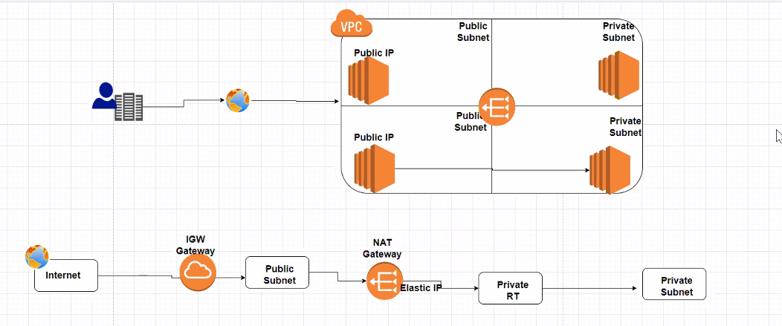

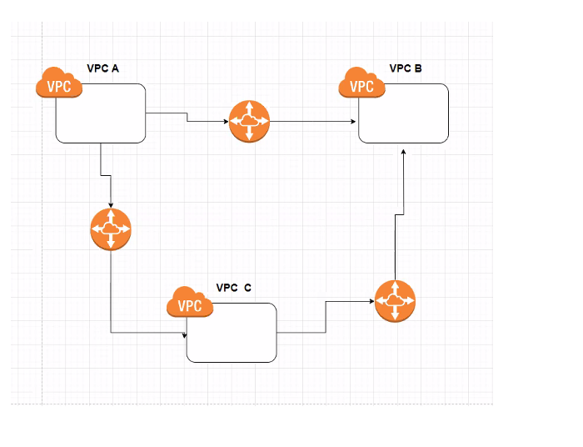

Peering Connection

1 - Choose your requester and Accepter between your targeted VPCs

2 - Make sure there is no Same or Overlapping CIDR

3 - Raise Peering Connection Request

4 - Accept that Request

5 - Do the Route Entry

Lab

1 - Choose TWO VPC with SAME CIDR

2- Follow the below steps to create a VPC Peering Connection and see what is the outcome

3 - Choose TWO VPC with Different CIDR

4 - Follow the below steps to create a VPC Peering COnnection and see if it is Active.

- Choose your two VPC

Second VPC can be the Default VPC or you have to create a new VPC without same Same CIDR or Overlapping CIDR

- Choose one as accepter and other as Requester

Region 1 – Mumbai ( Requester)

vpc-0ed69a659196d2883

192.168.0.0/16

Region 2 - Singapore ( accepter)

vpc-0e2d8c80bb53bbd93

172.31.0.0/16

Go to the Peering connections at the VPC Dashboard

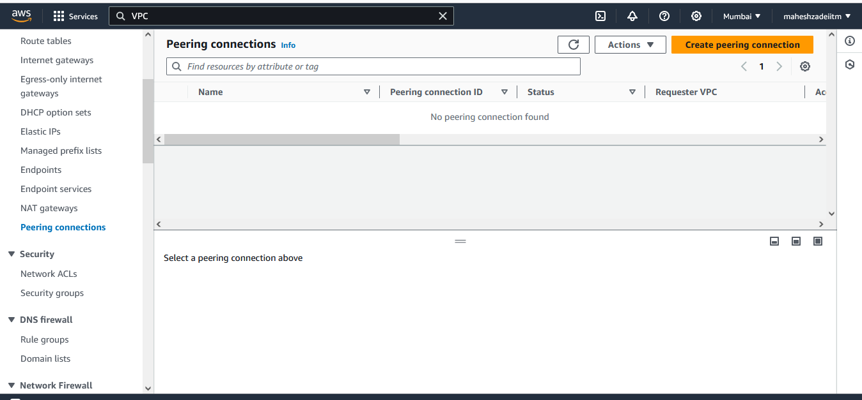

Create peering connection

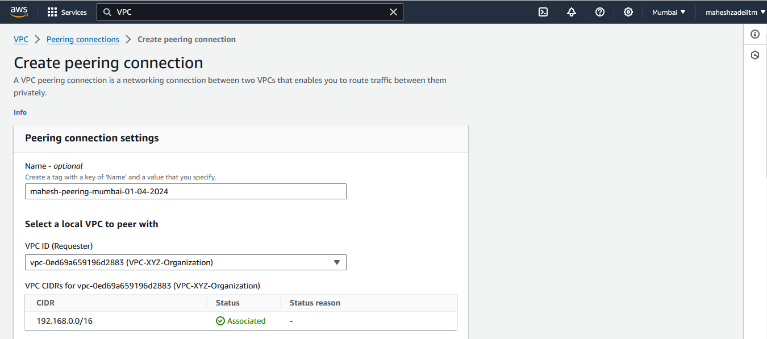

Choose your Requester VPC ID

vpc-0ed69a659196d2883

Give your Accepter VPC ID ( Singapore region)

vpc-0e2d8c80bb53bbd93

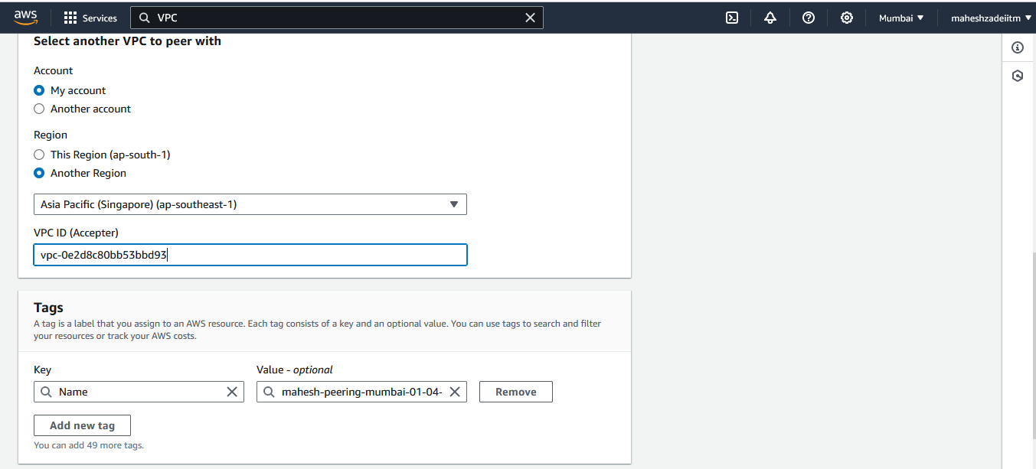

Click Create peering connection

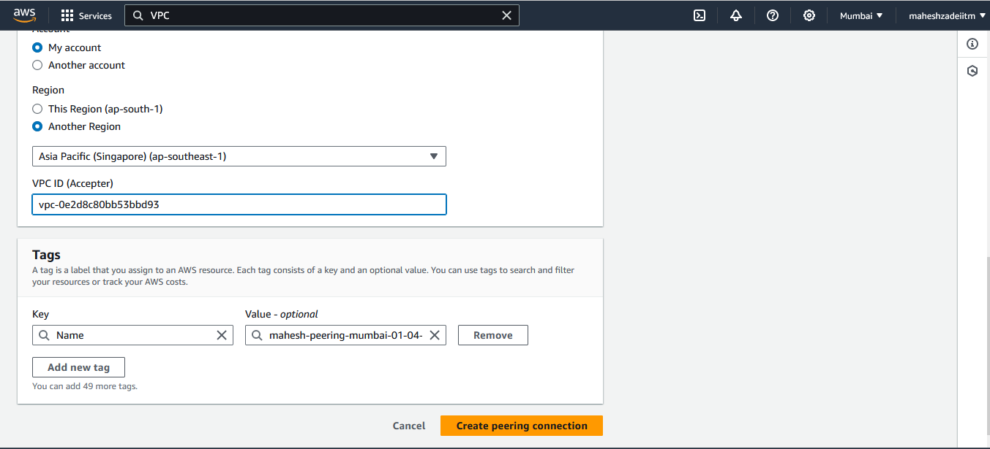

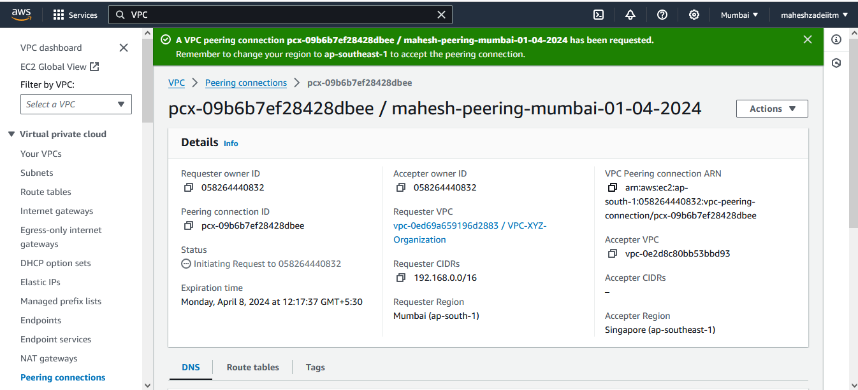

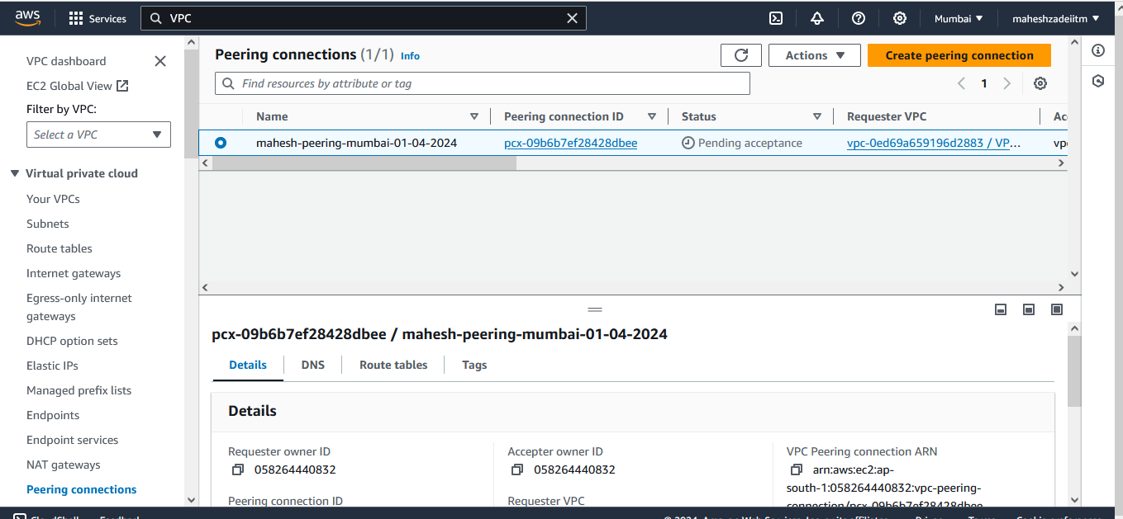

Now the Status is "Pending acceptance"

Now Go to the Accepter Region

Choose the request ID >>> Actions >>>>> Accept Request

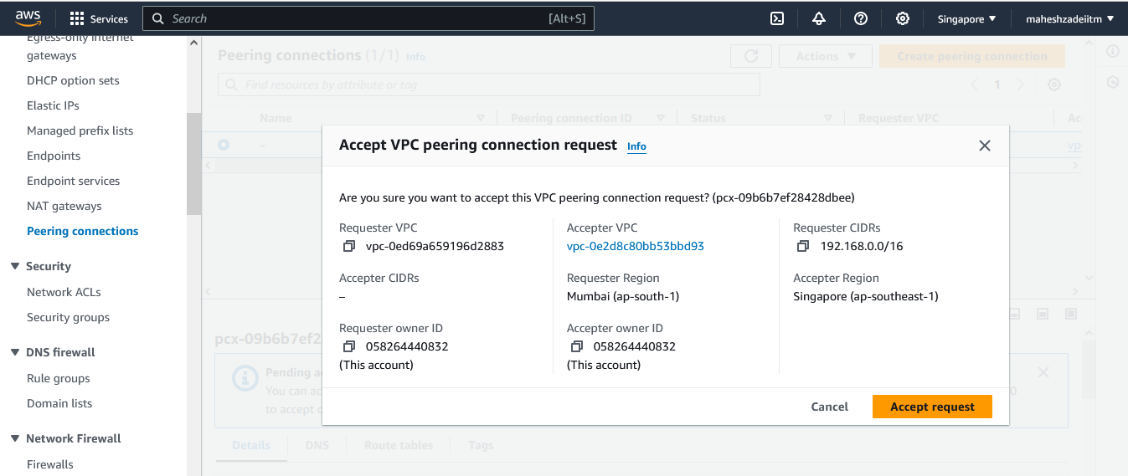

Now the status will become Active

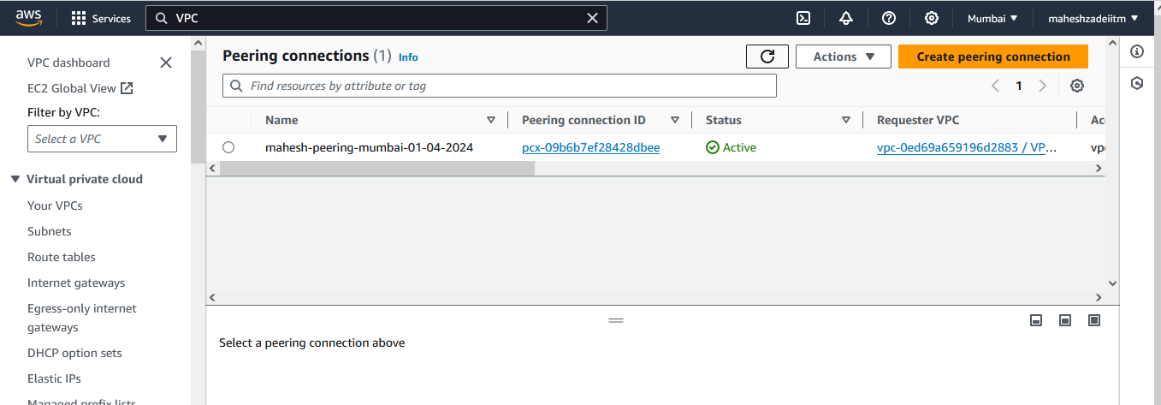

Go the requester VPC

GO to the ROutes

Choose the Public RT >>> Routes >>> Add Route >>> give the Accepter VPC CIDR Range as a Destination and Click on Target >>> choose Peering COnnection >>> Double Click >> Save.

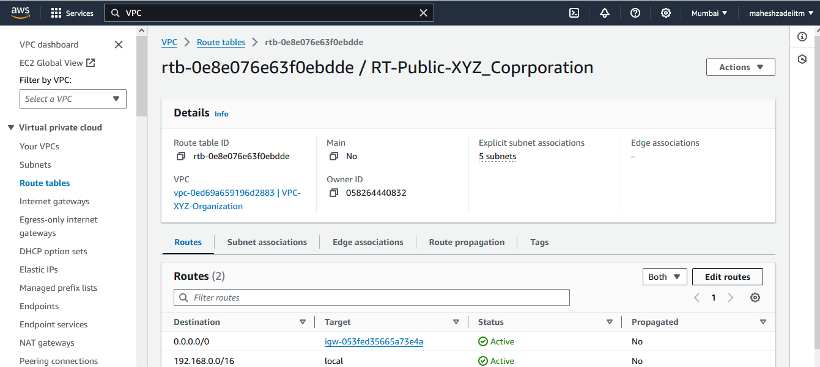

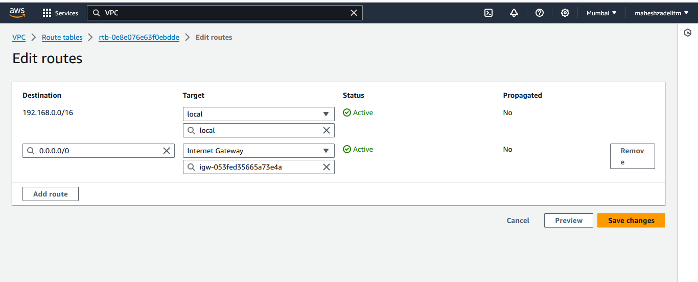

Add route

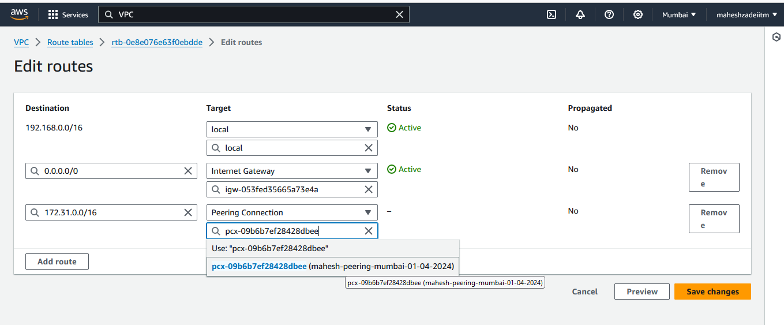

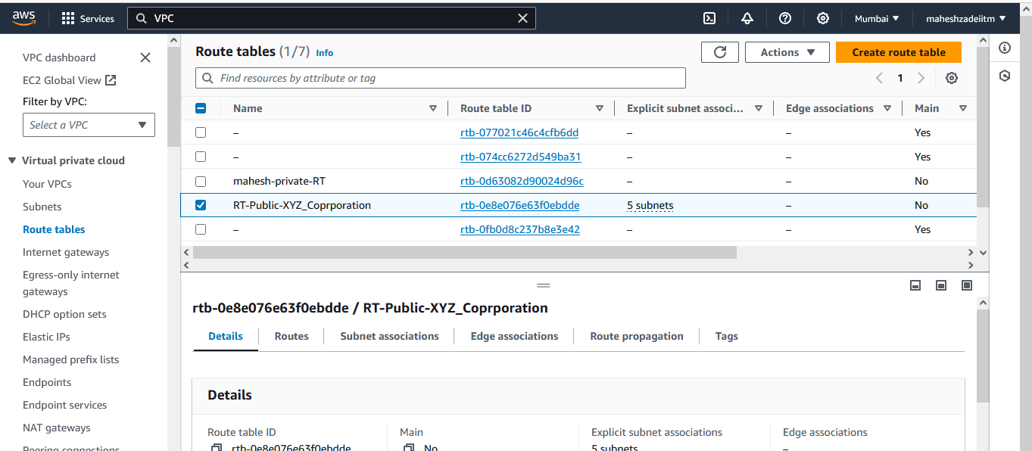

Go the Accepter VPC

GO to the ROutes

Choose the RT >>> Routes >>> Add Route >>> give the Requester VPC CIDR Range as a Destination and Click on Target >>> choose Peering COnnection >>> Double Click >> Save.

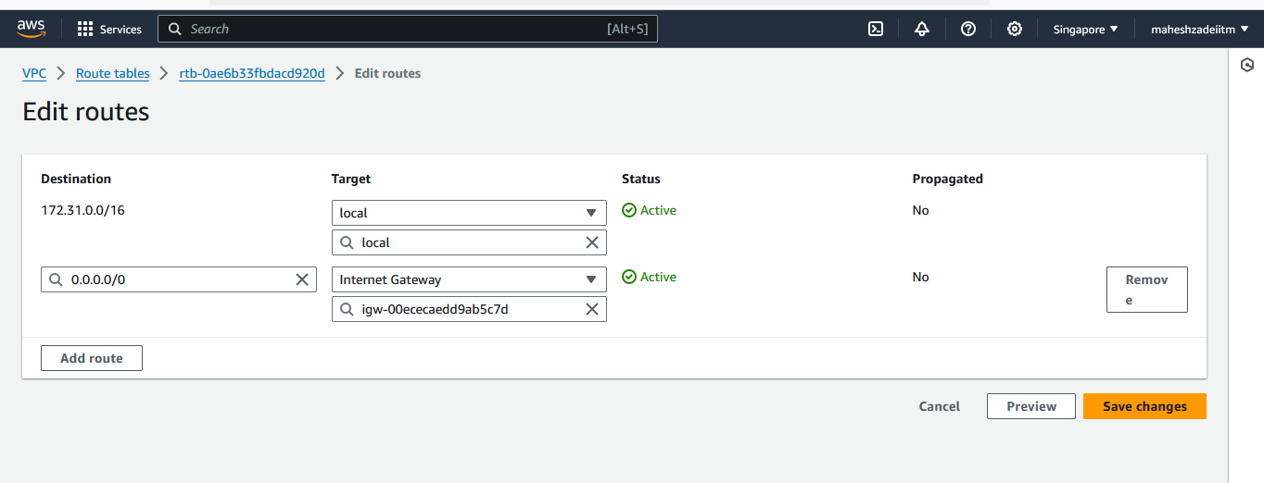

Put the CIDR of the requester VPC

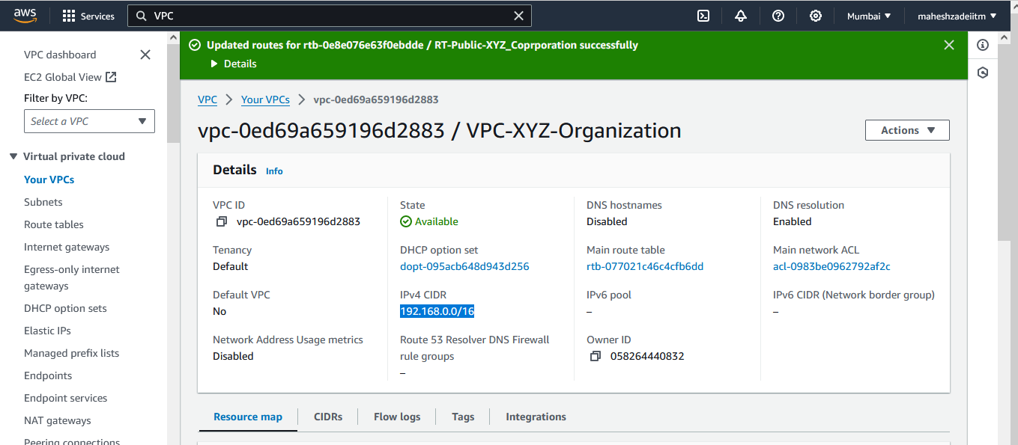

Requester Rote Table

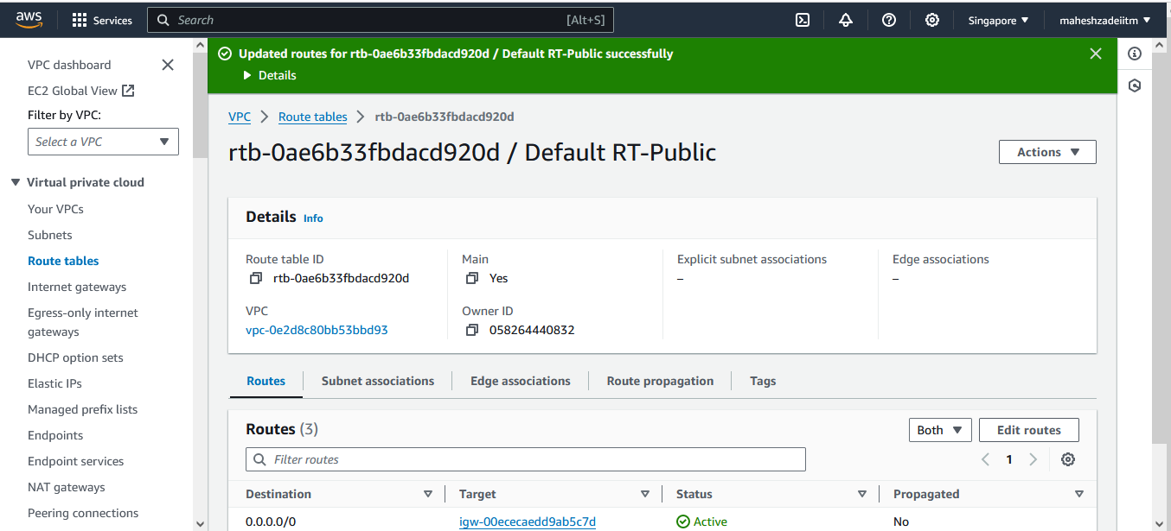

Go to the First VPC

Launch a Windows EC2 with Public IP in public Subnet

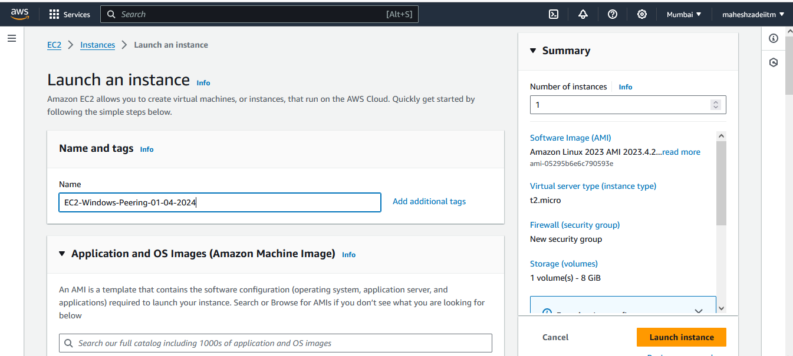

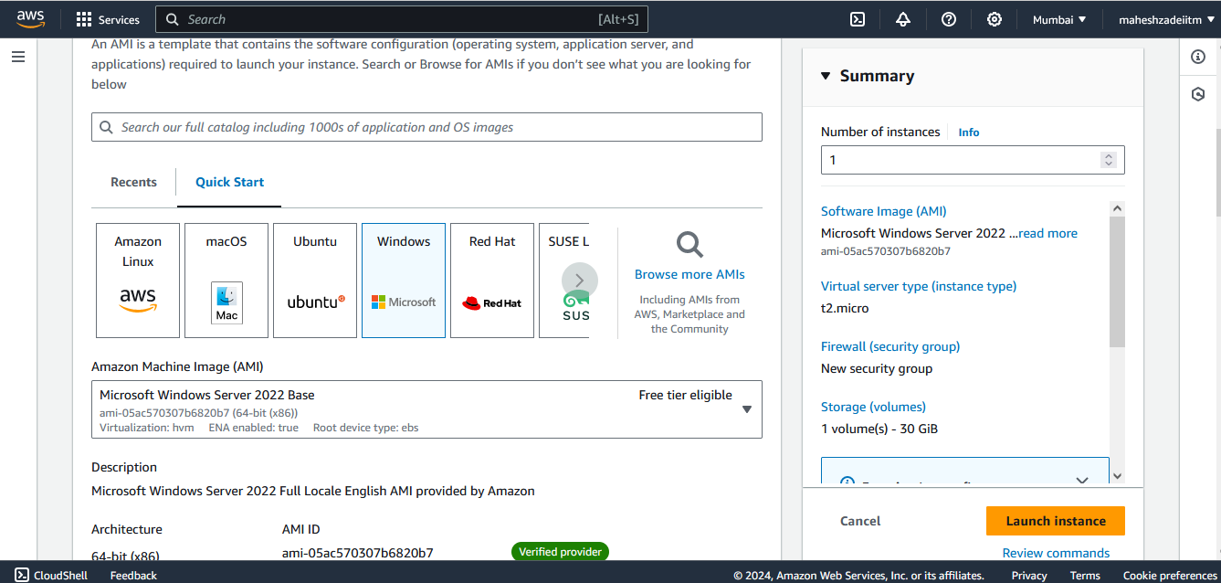

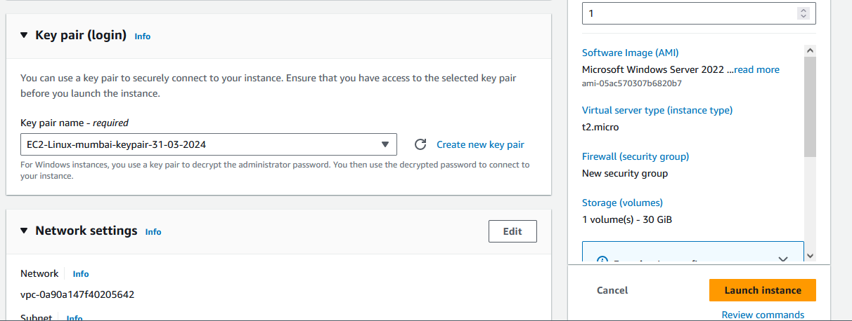

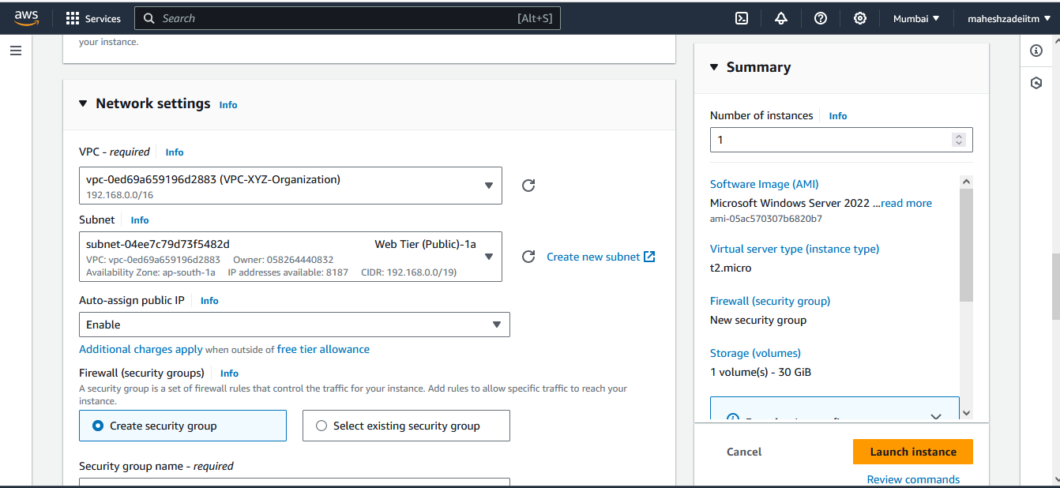

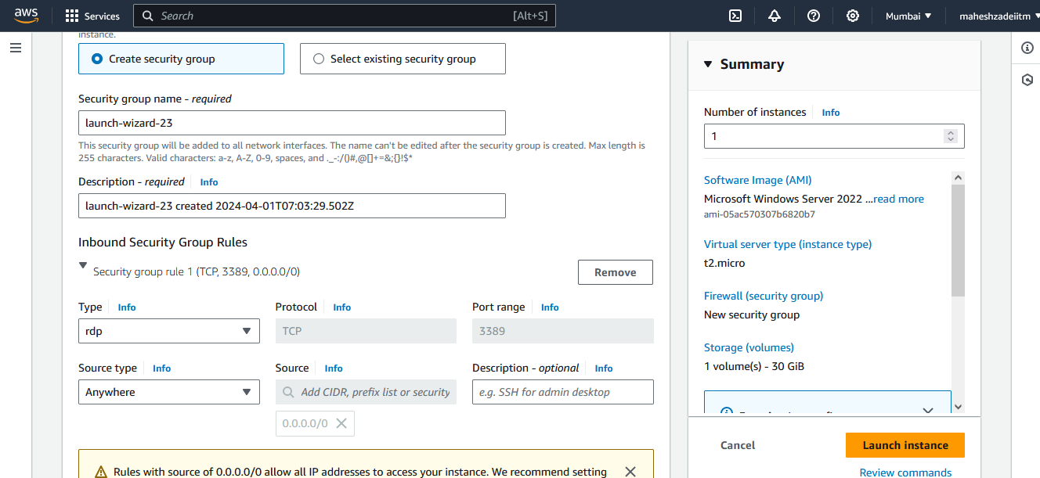

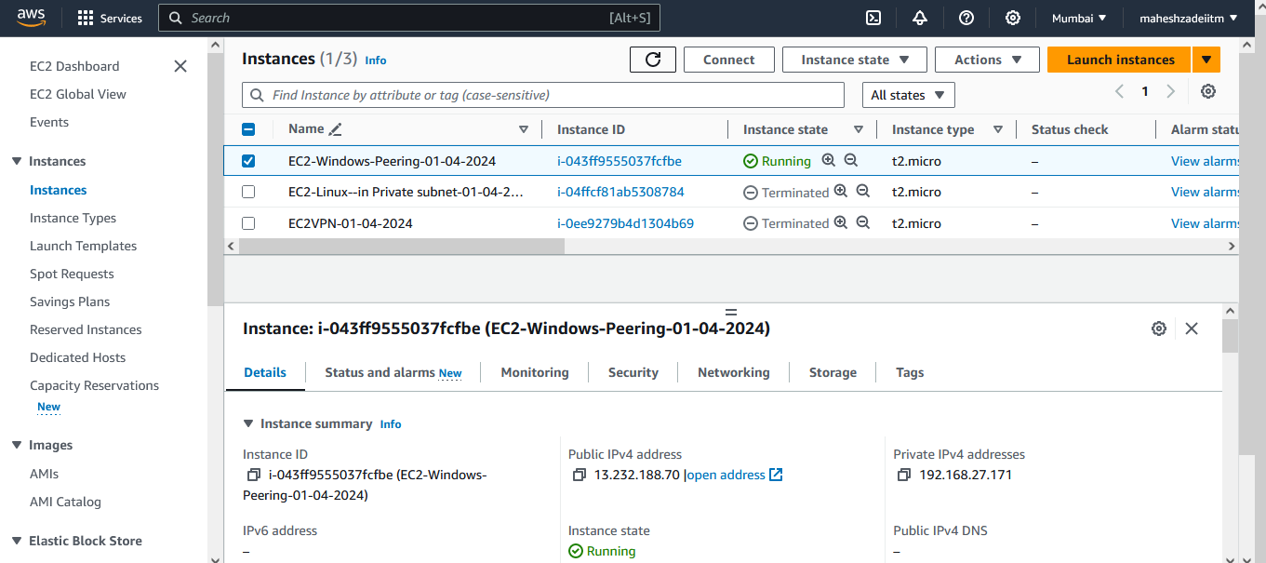

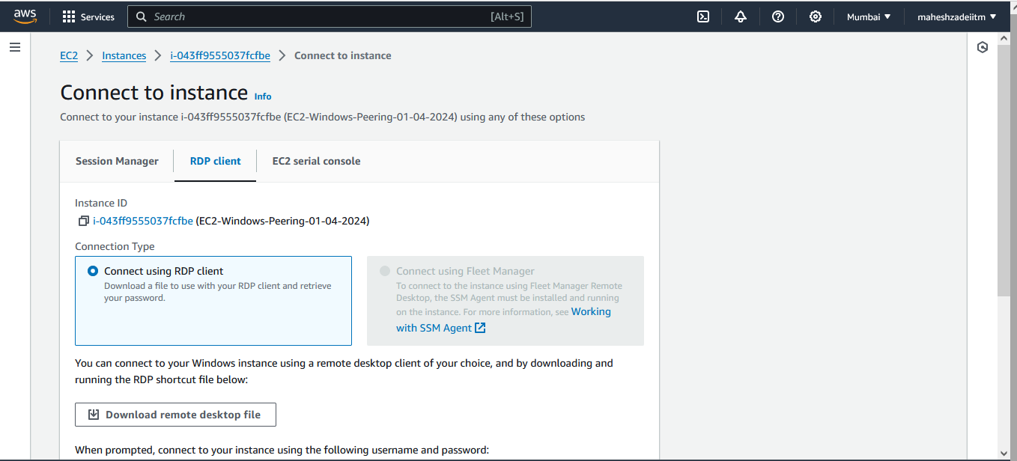

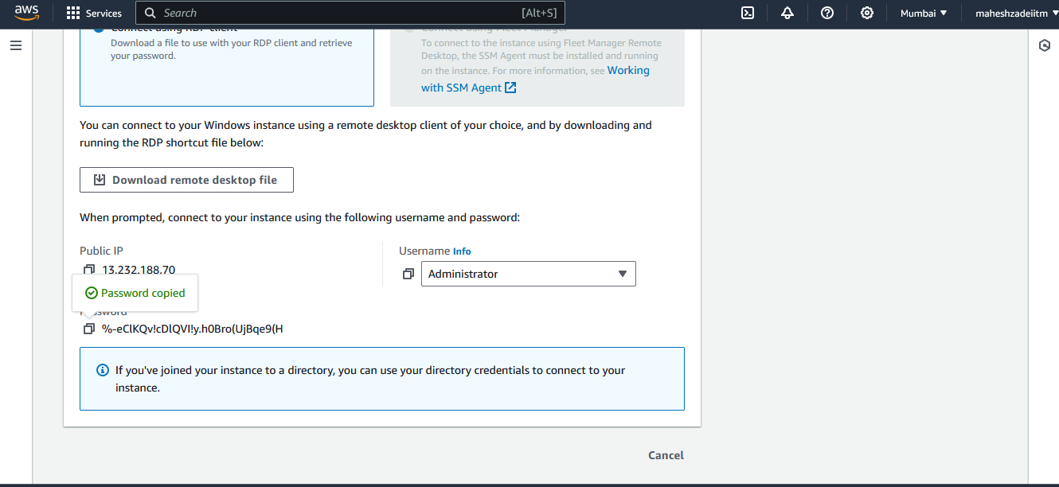

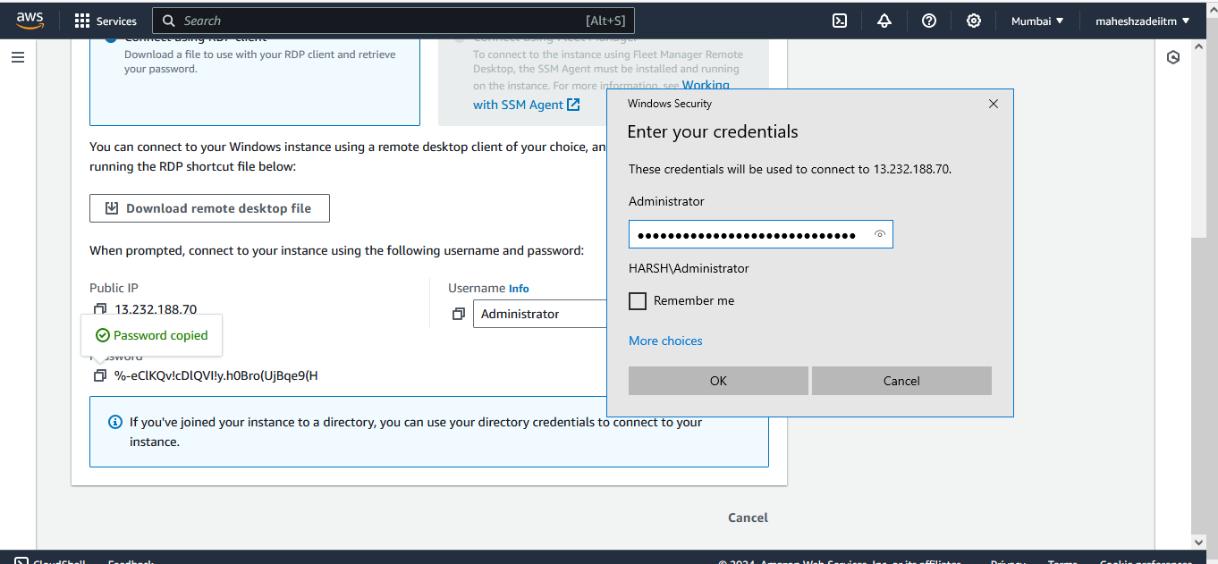

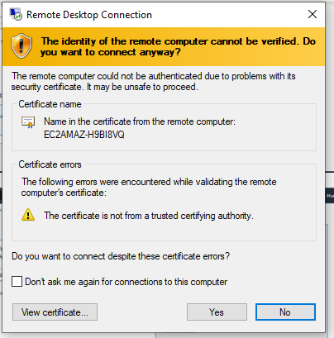

Copy Mobaxterm and Mumbai EC2 windows Keypair in Ec2 windows Machine to connect the Linux EC2 Instance in other private subnet VPC in Singapore .

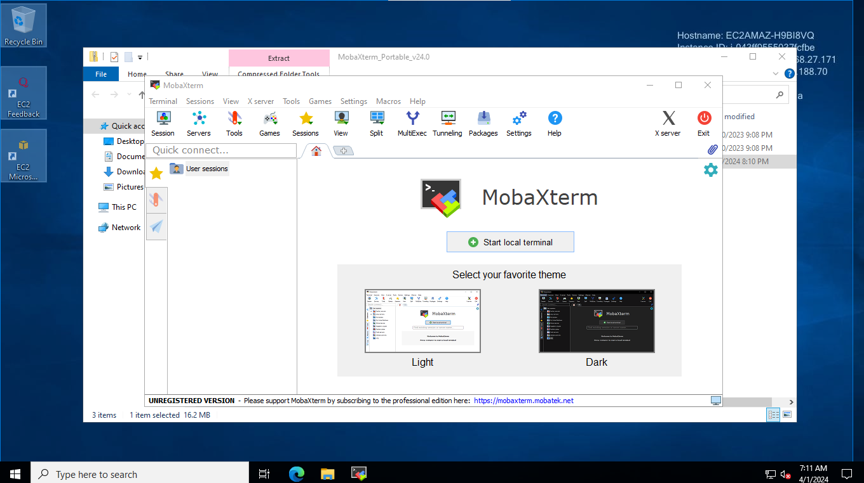

Go to the Second VPC

Launch a Linux EC2 without Public IP in public subnet

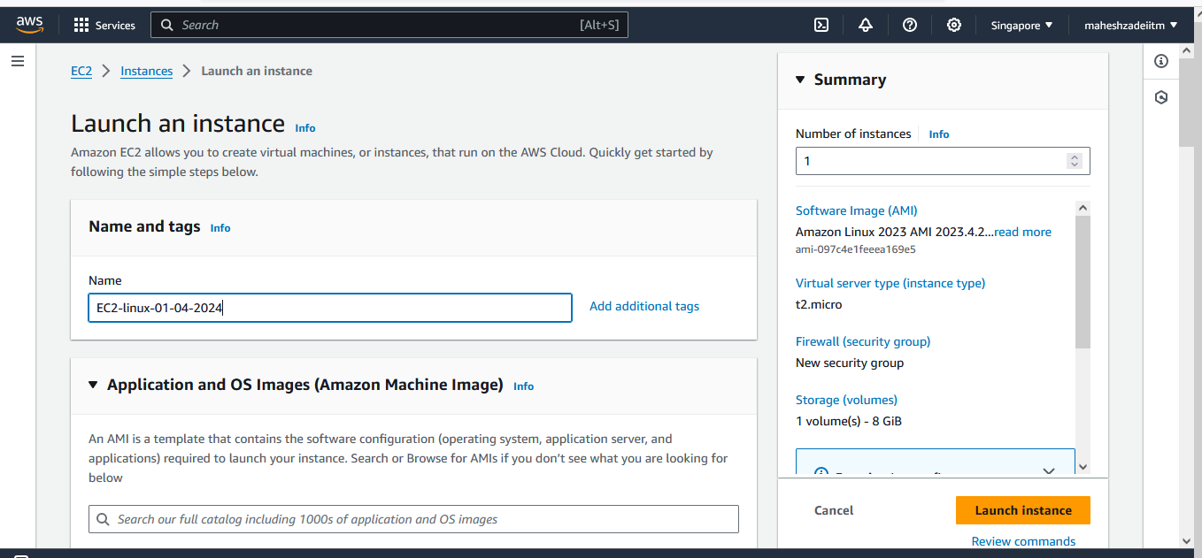

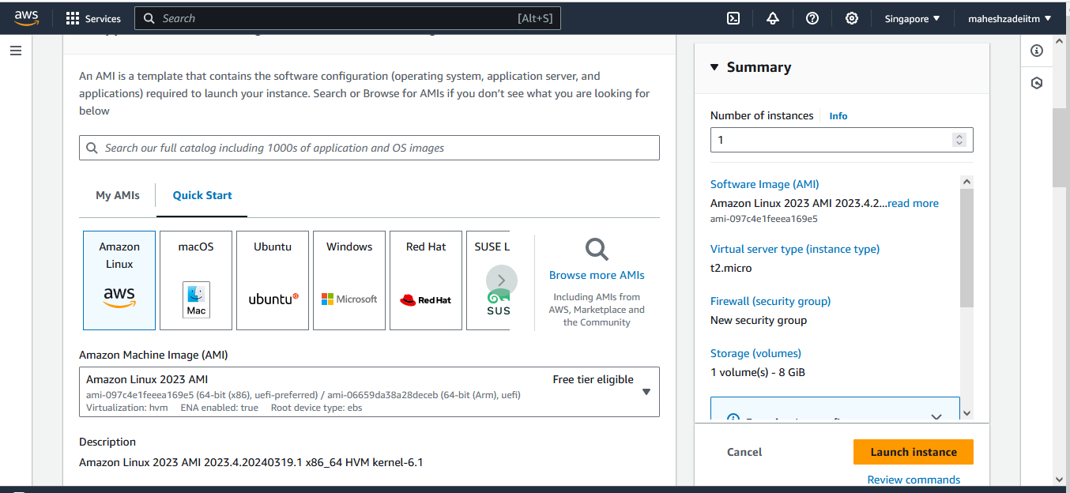

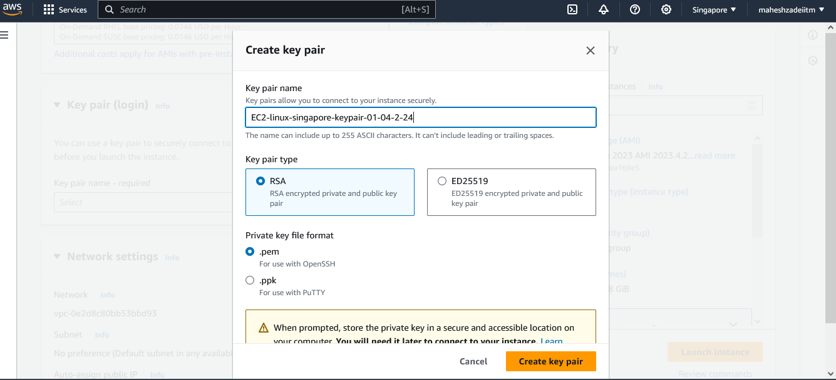

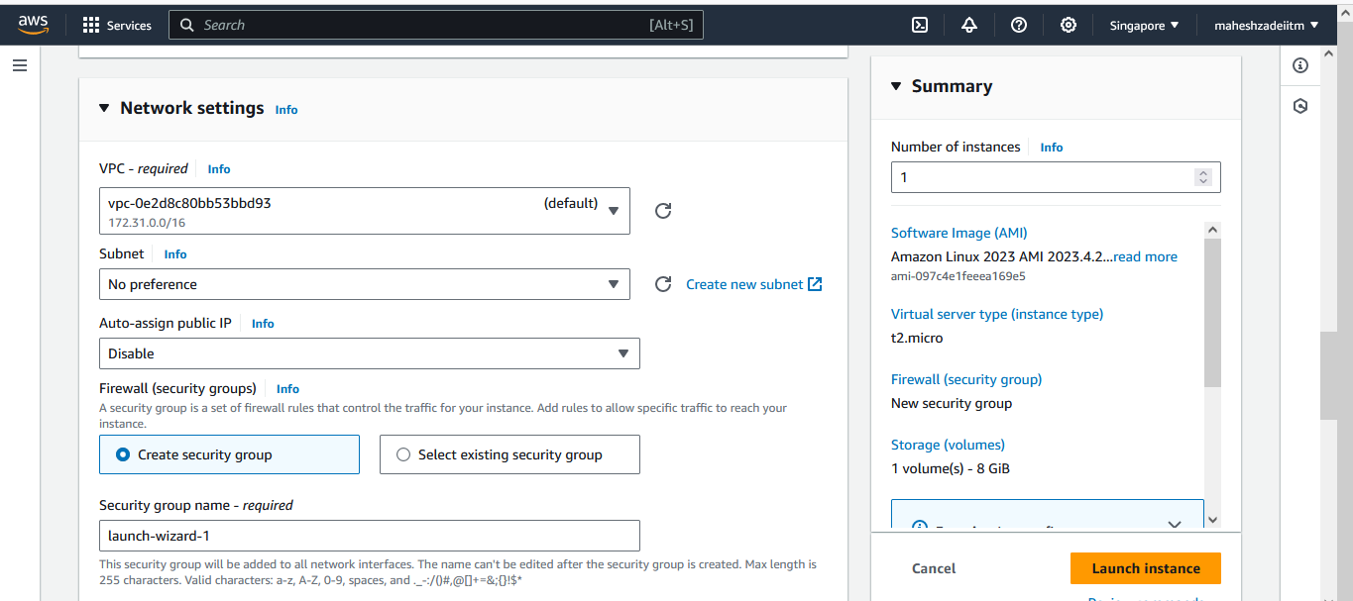

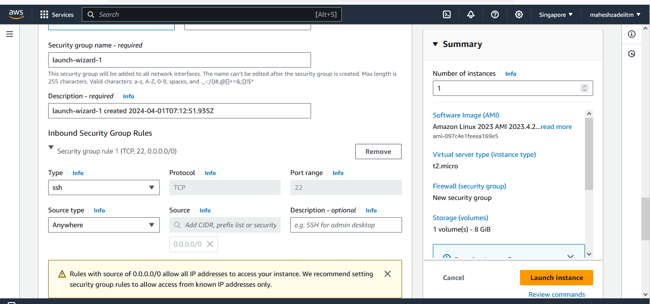

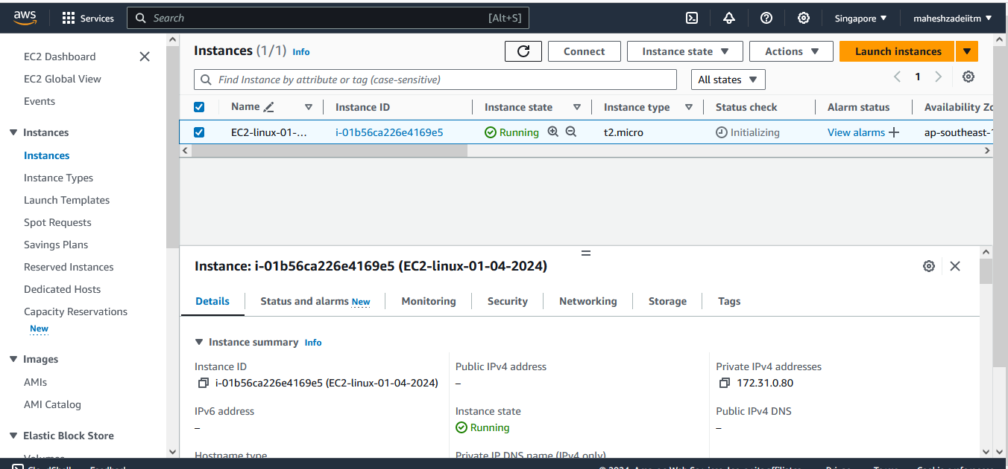

Now Copy the Private IP of EC2 Linux machine from Singapore DC which don’t have the Public IP

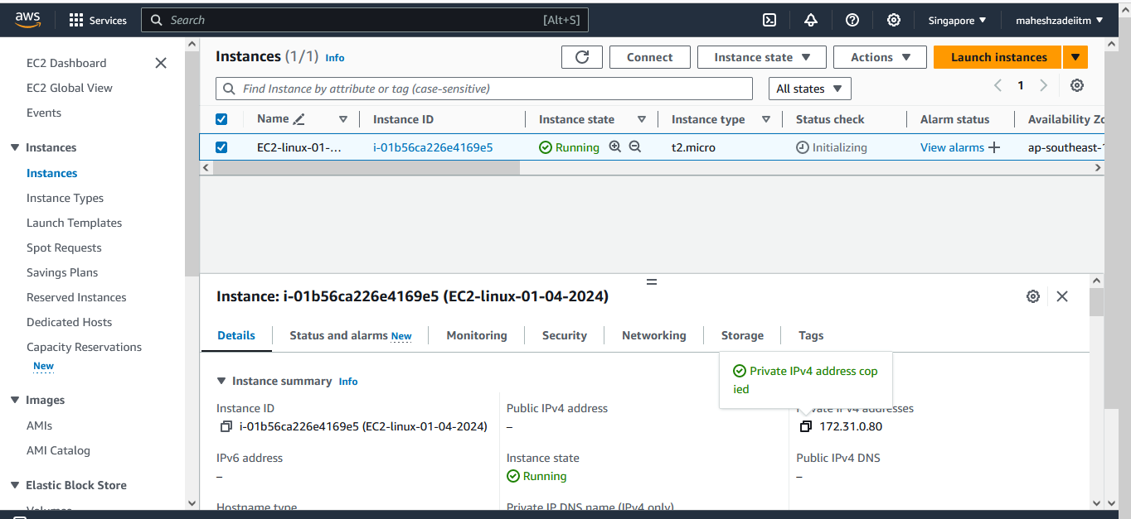

Paste the private IP in windows EC2 Instacne Mobaxterm

Copy Linux machine key pair in windows EC2 Instacne in Mumbai region machine and then put the Private IP , user name and upload the private key for Singapore region

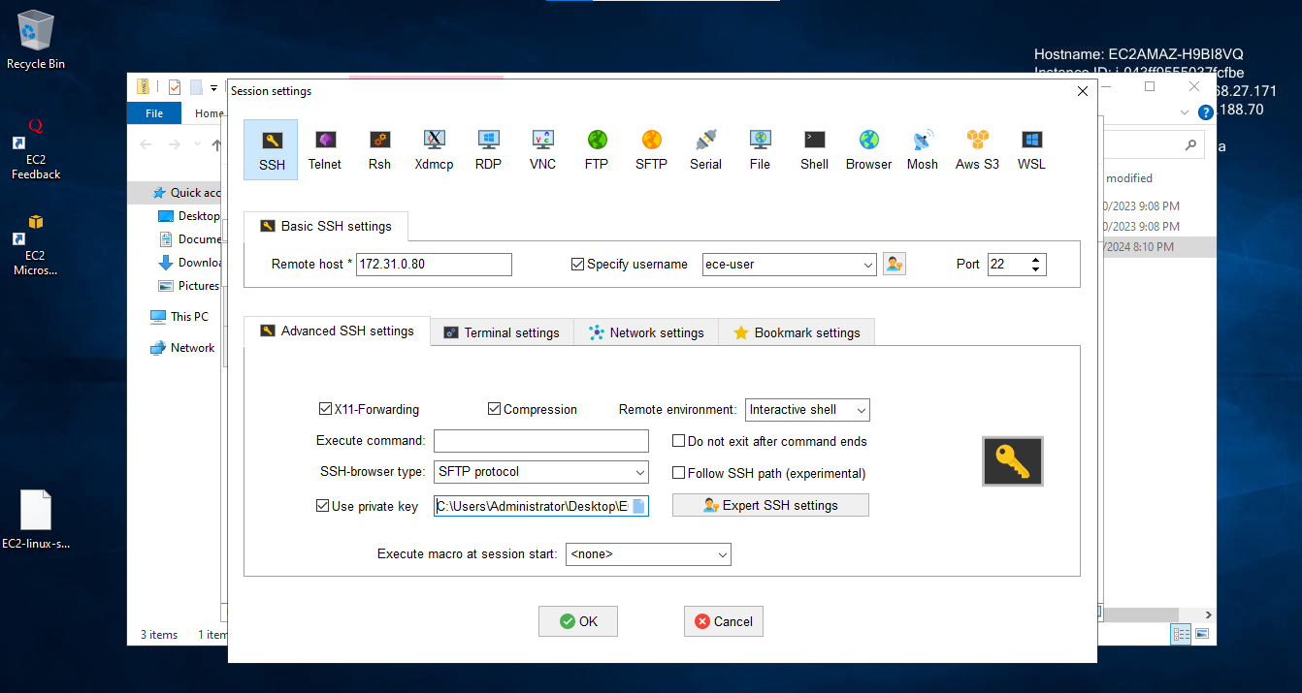

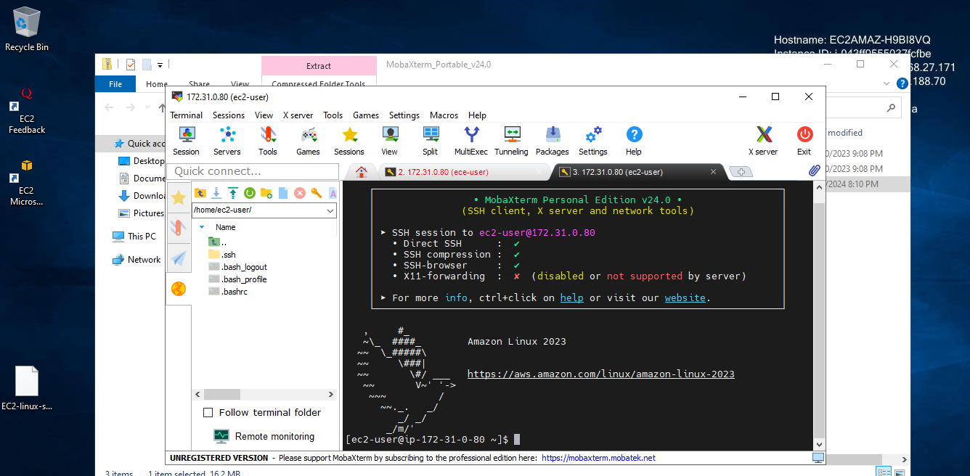

NOw login the windows EC2 and try to connect the LInux EC2 with the PRivate IP

if that is reachable or connecting, your Peering connection is working as expected

Its done Now .

Delete your Peering Connection

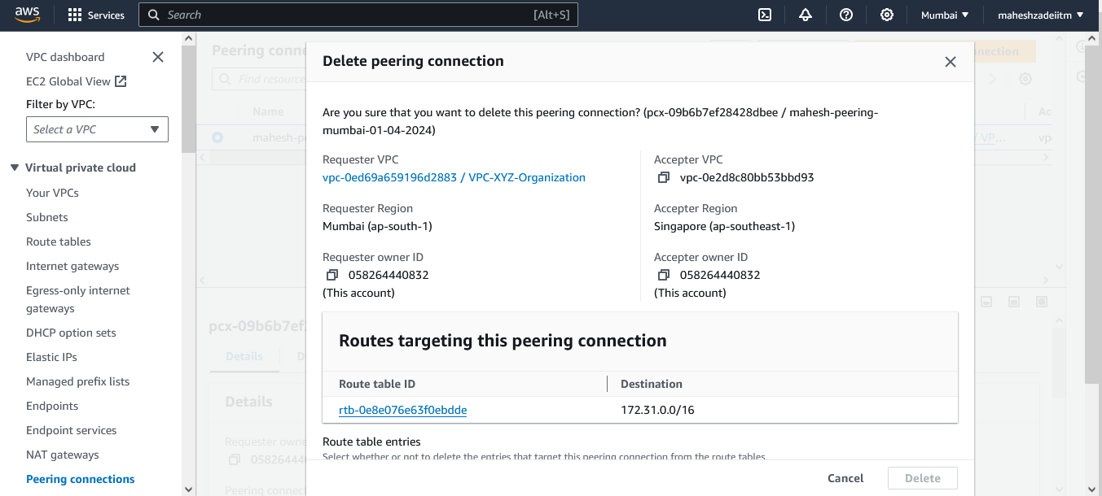

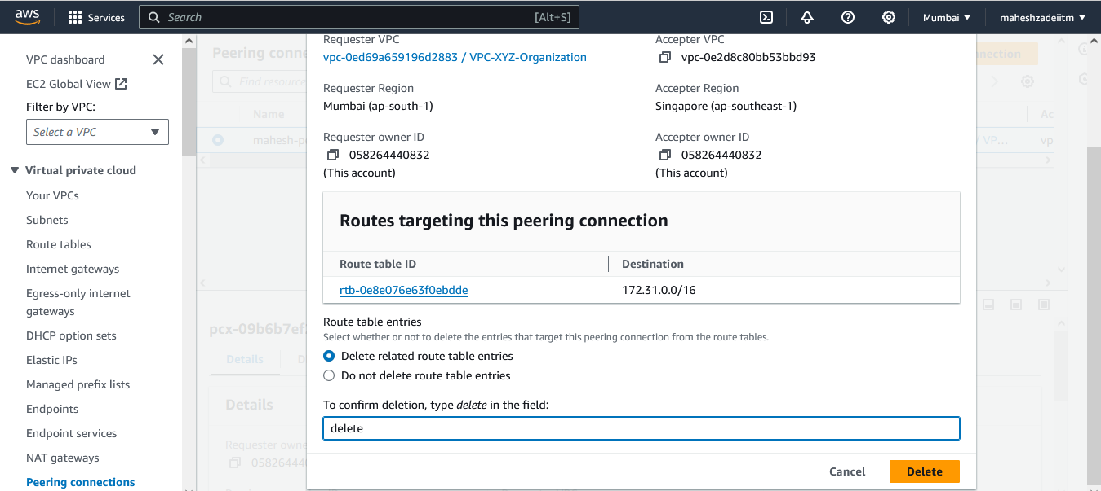

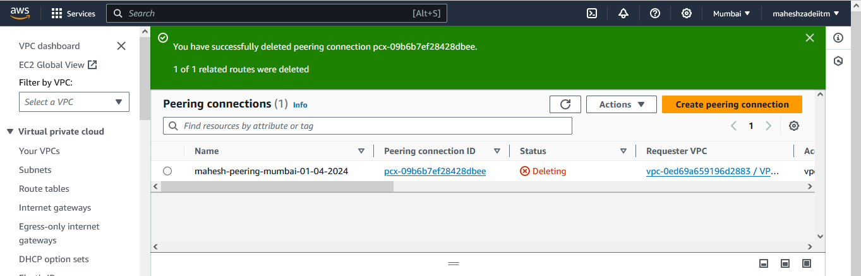

Try again to test the connectivity >>> From windowsec2 to LInux with Private IP.

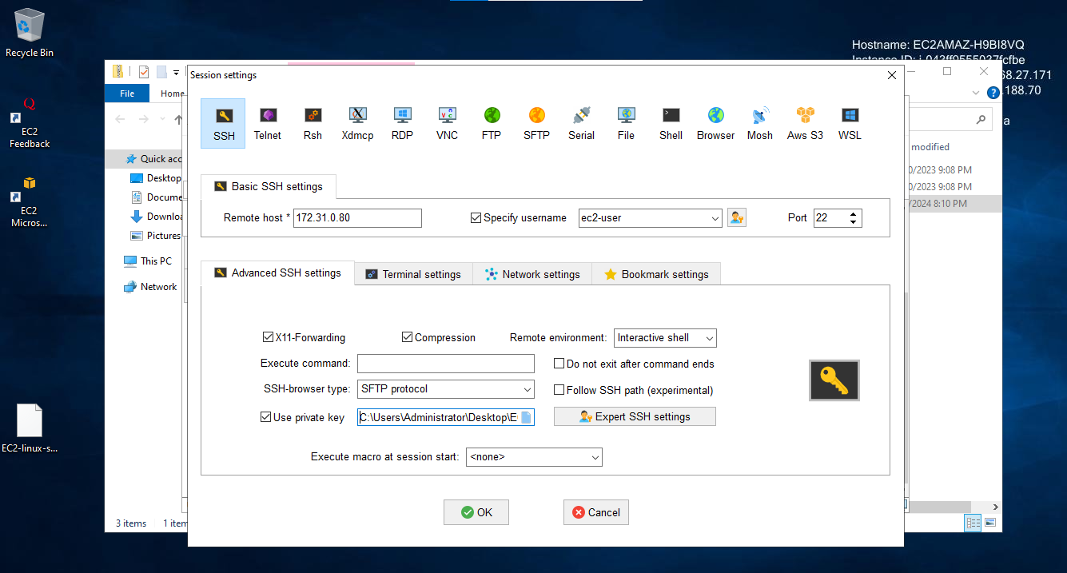

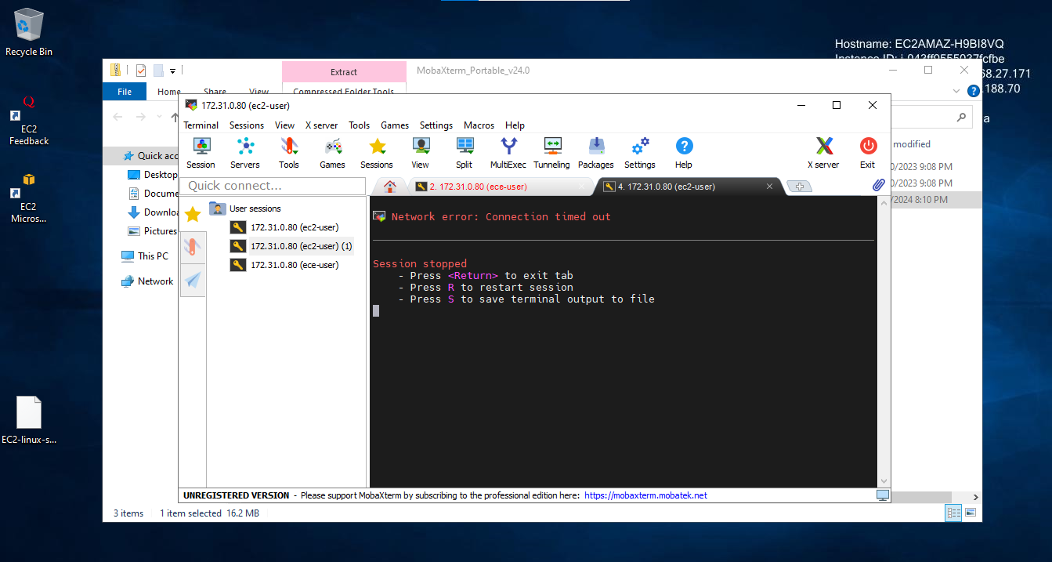

Unable to connect now from Windows EV2 Instacne from Mumbai Region

Delete your EC2 from Region 2

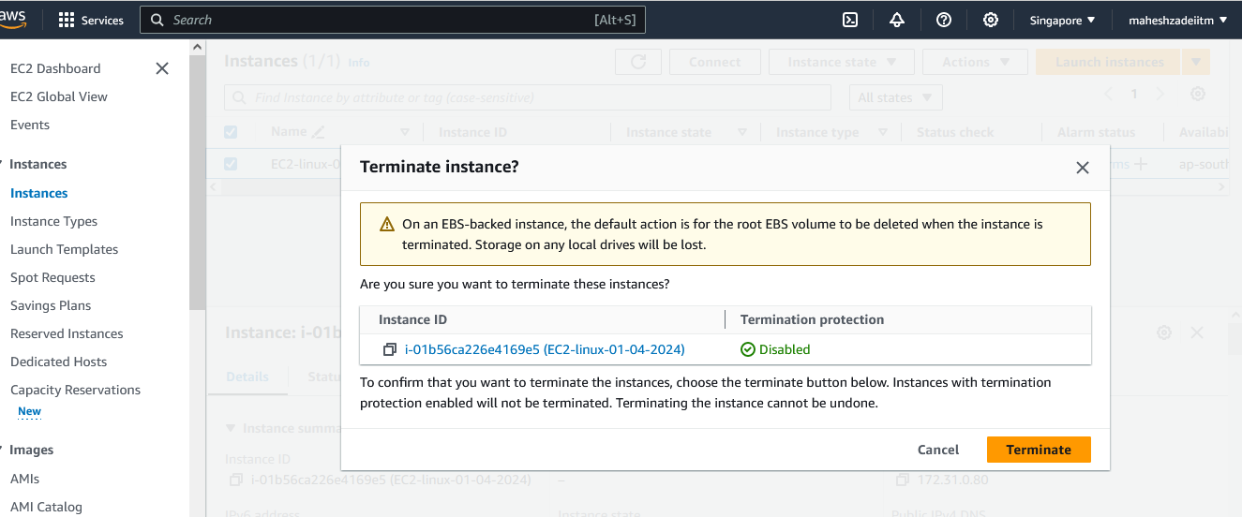

Choose your Region 3

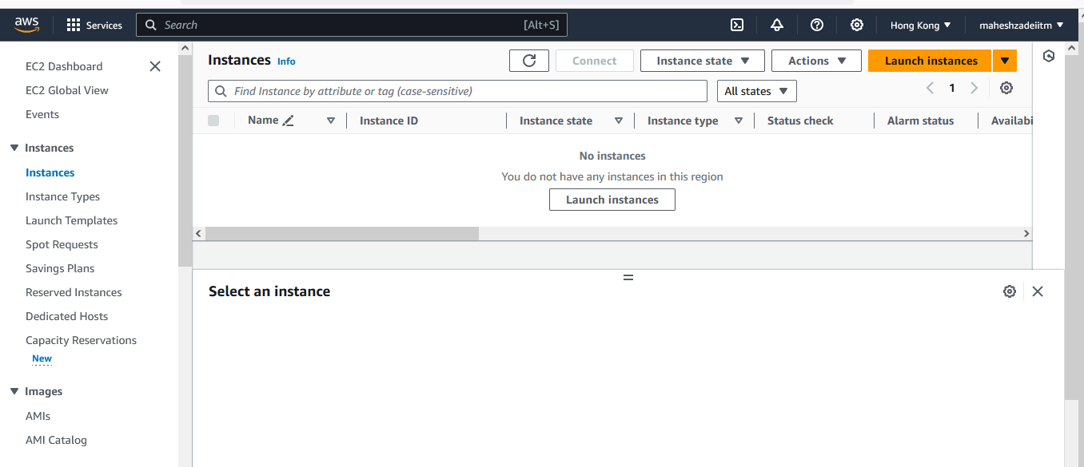

Launch a New VPC or choose the existing VPC ( We have Selected the hongkong Region and default VPC )

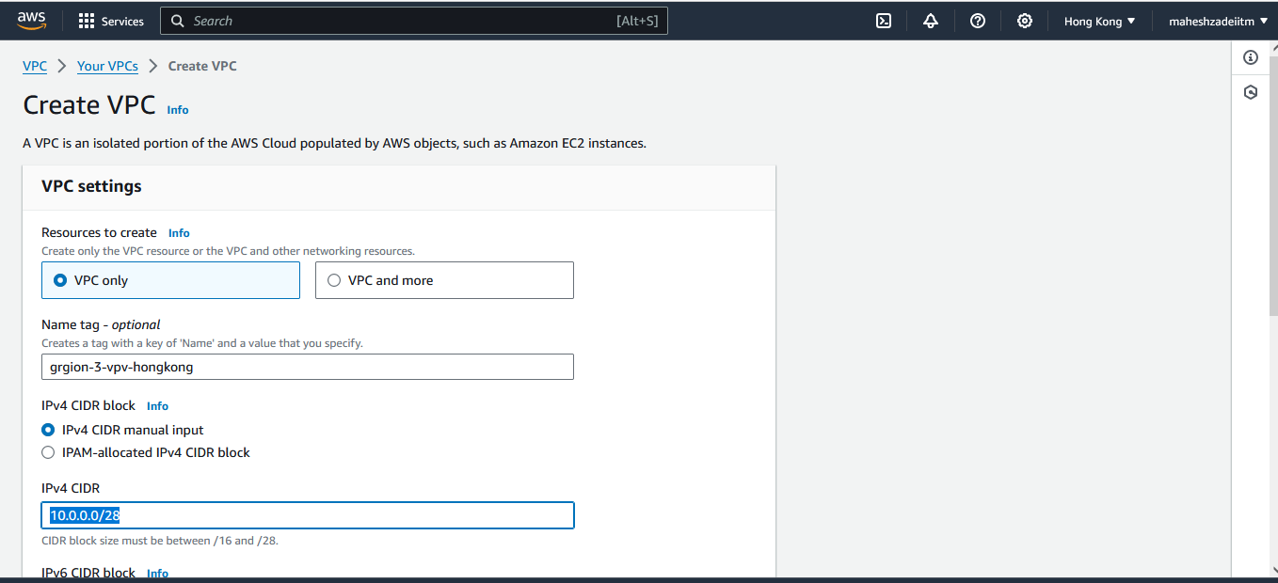

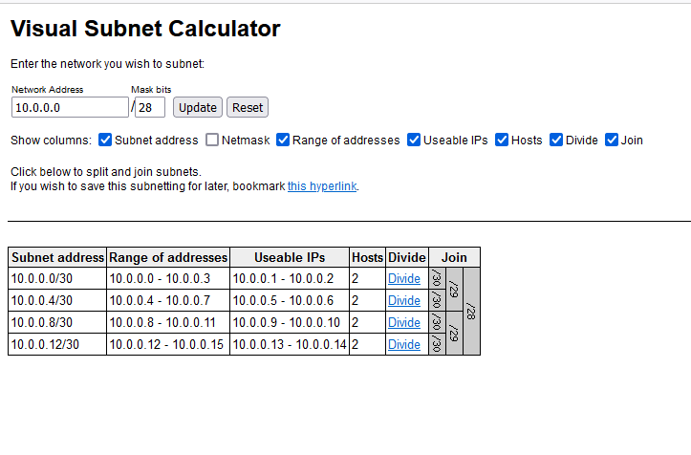

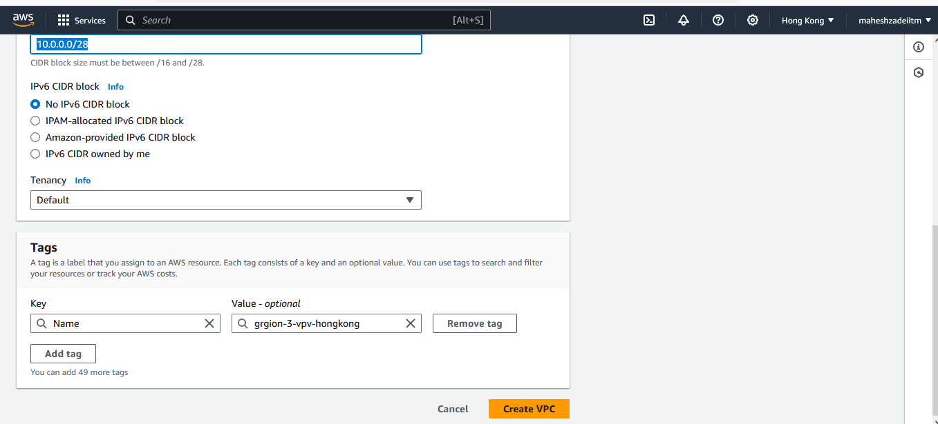

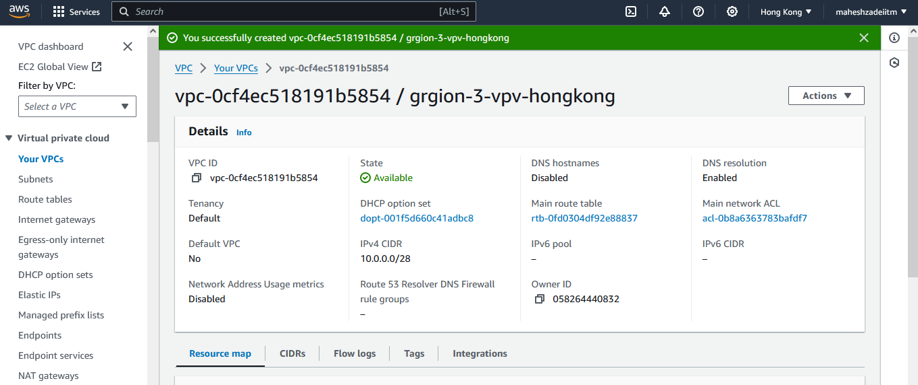

VPC Created in Honkong DC

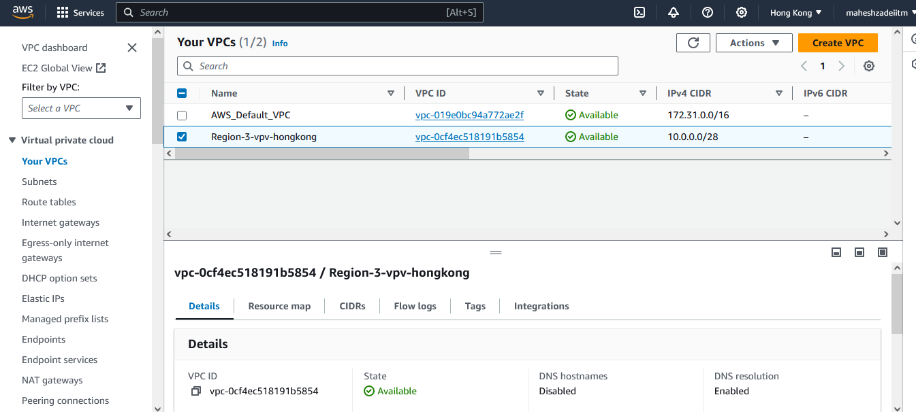

But make sure there is no Same or Overlapping CIDR

Region 1 – Mumbai ( Requester)

vpc-0ed69a659196d2883

192.168.0.0/16

Region 2 - Singapore ( accepter)

vpc-0e2d8c80bb53bbd93

172.31.0.0/16

Region-3 Hongkong vpc-0cf4ec518191b5854

10.0.0.0/28

Create a Peering connection from Region 2 to Region 3 VPC

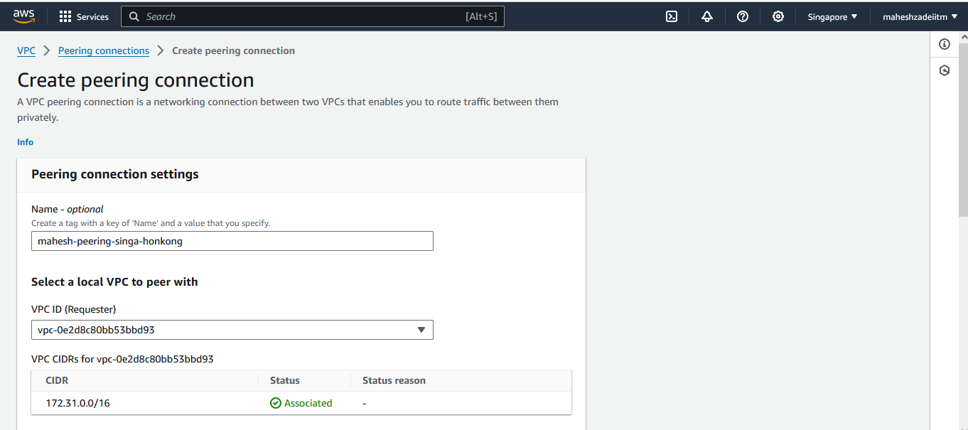

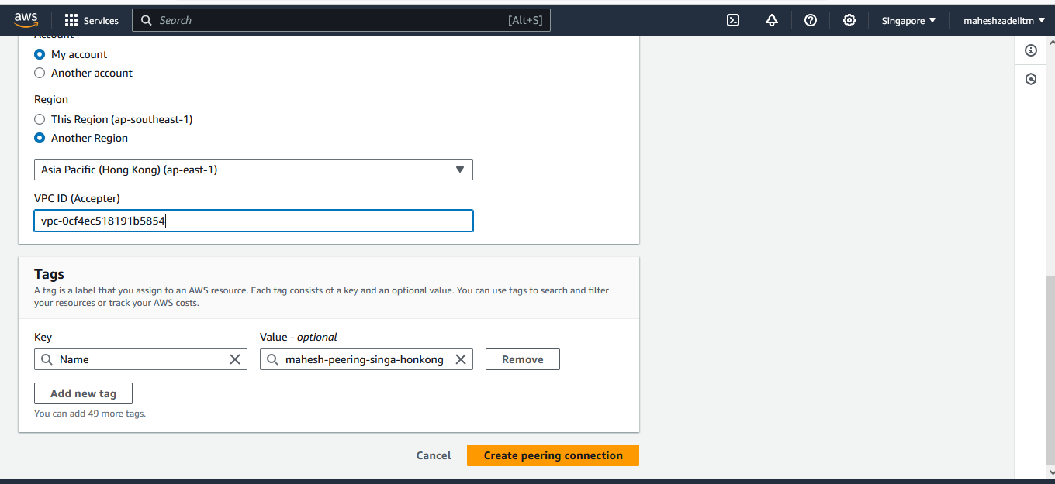

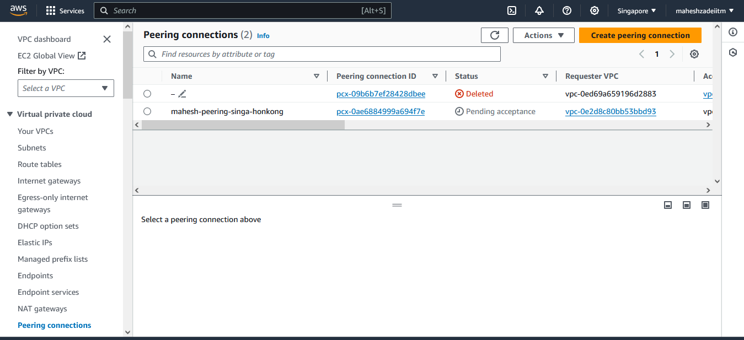

Accep the peering connection in hongkong DC

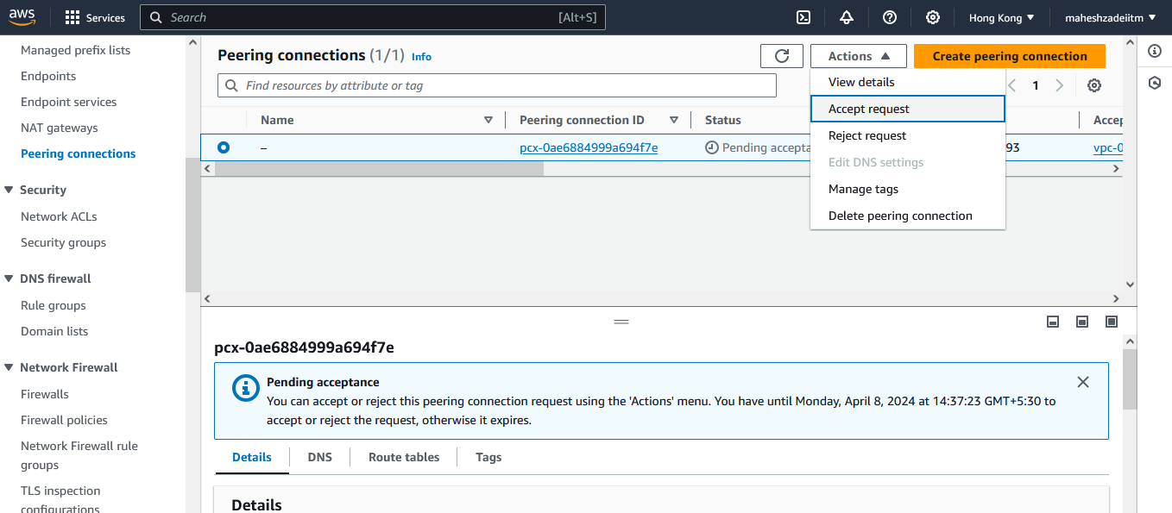

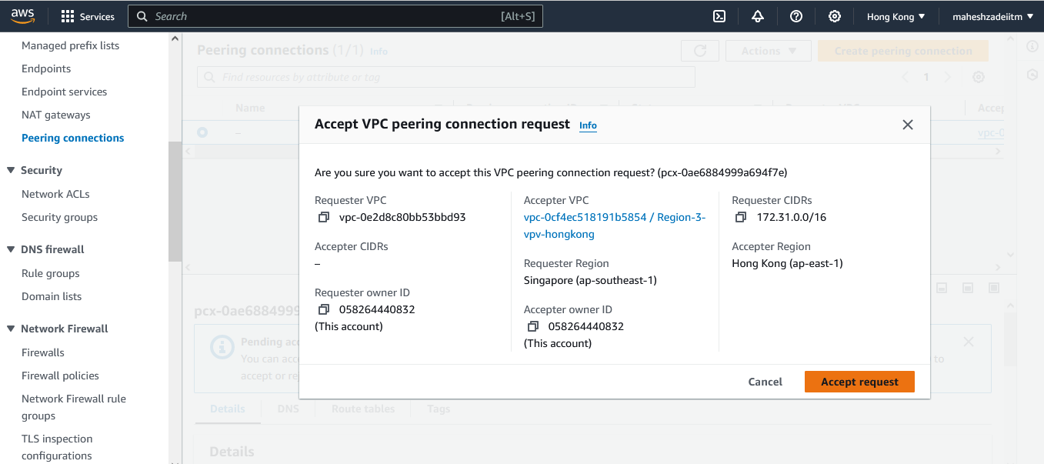

Now go to RT of Singapore DC and add the CIDR rage .

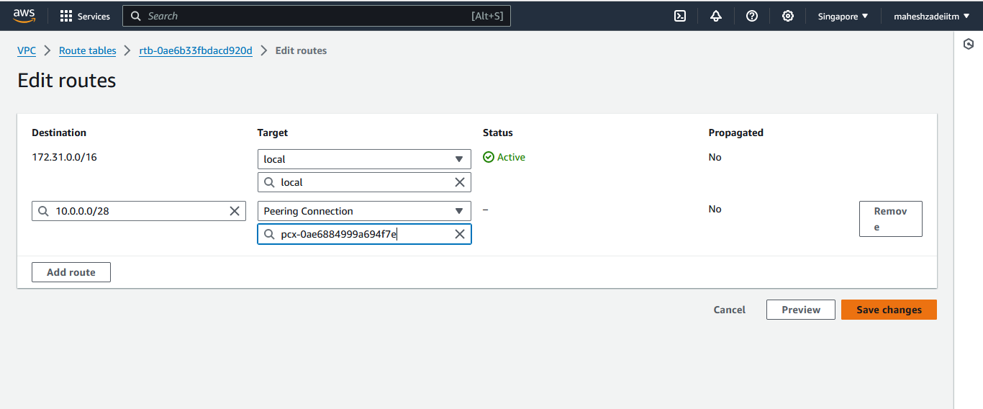

Save changes

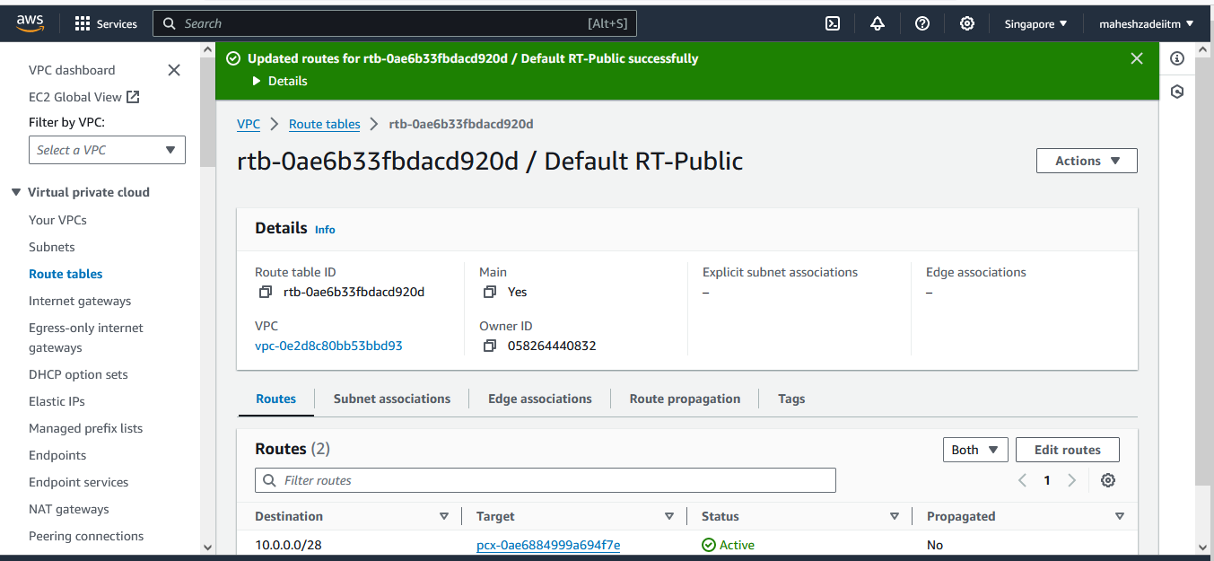

RT Hongkong reconfigured .

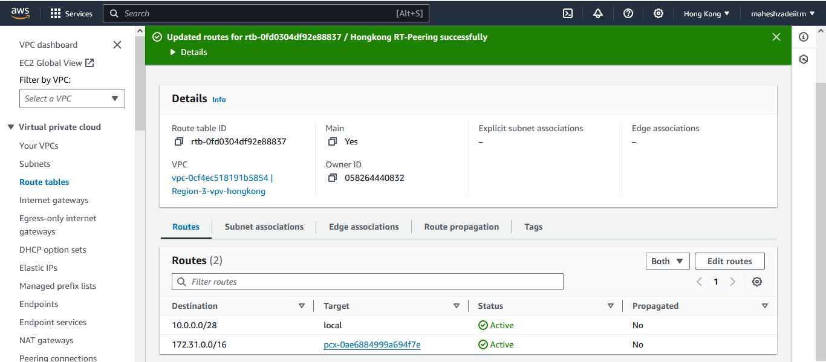

Now

There is a Peering connection from Region 1 to 2

There is a Peering connection from Region 2 to 3

And

There is one Windows EC2 in the REgion 1

Region 2 - EC2 is already deleted above

Now launch a New Linux EC2 in the region 3

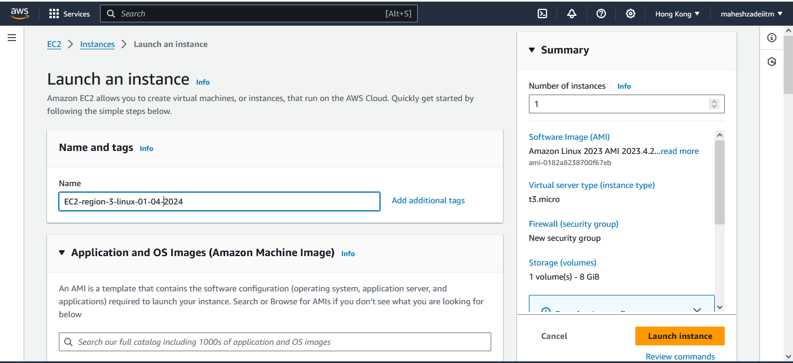

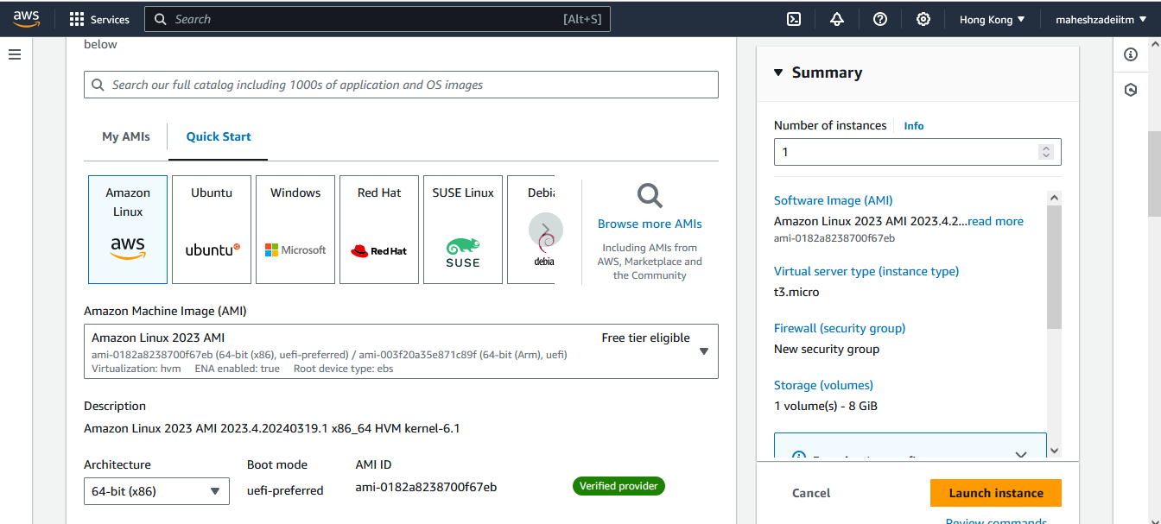

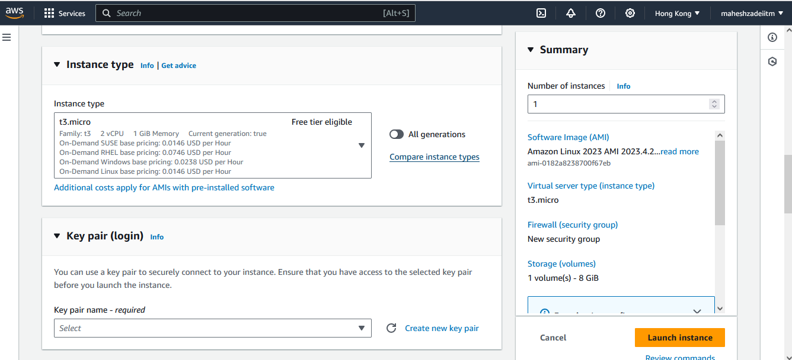

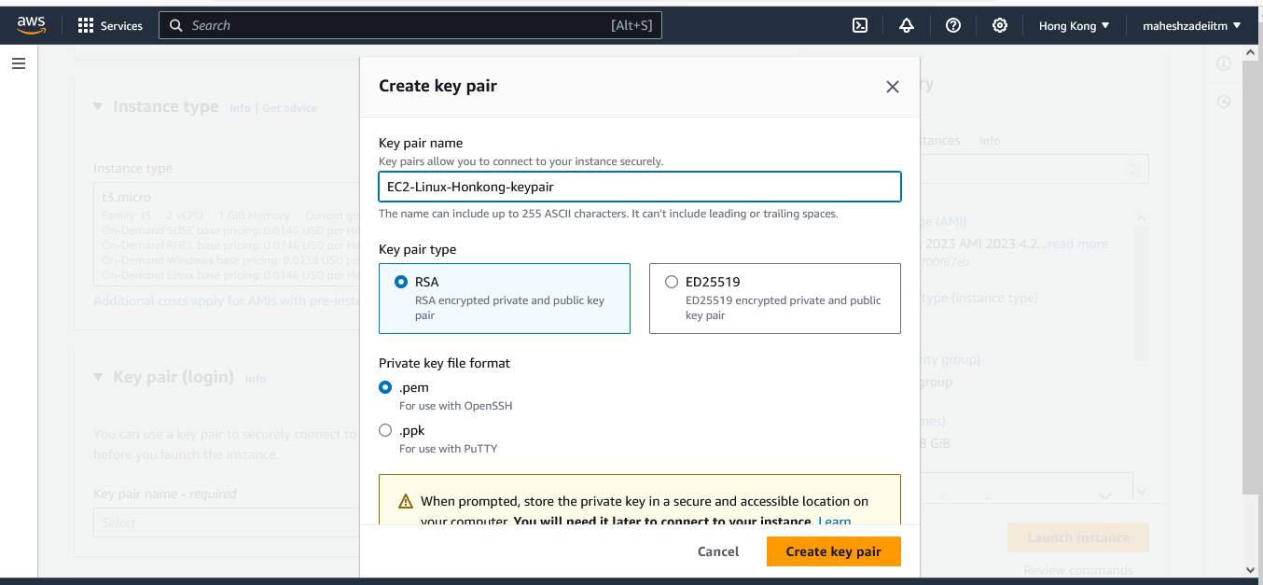

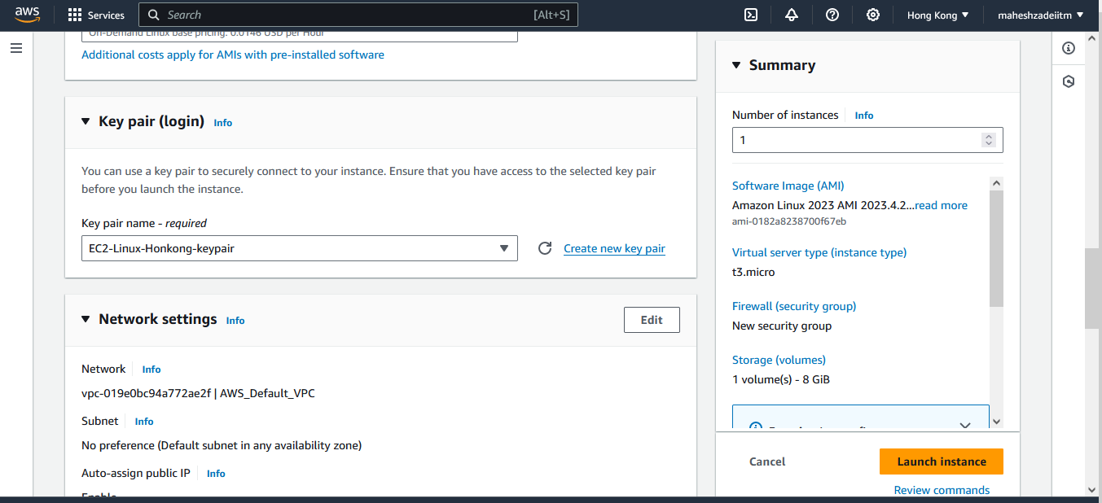

As sunet is not showing we are created a subnet in hong kong region

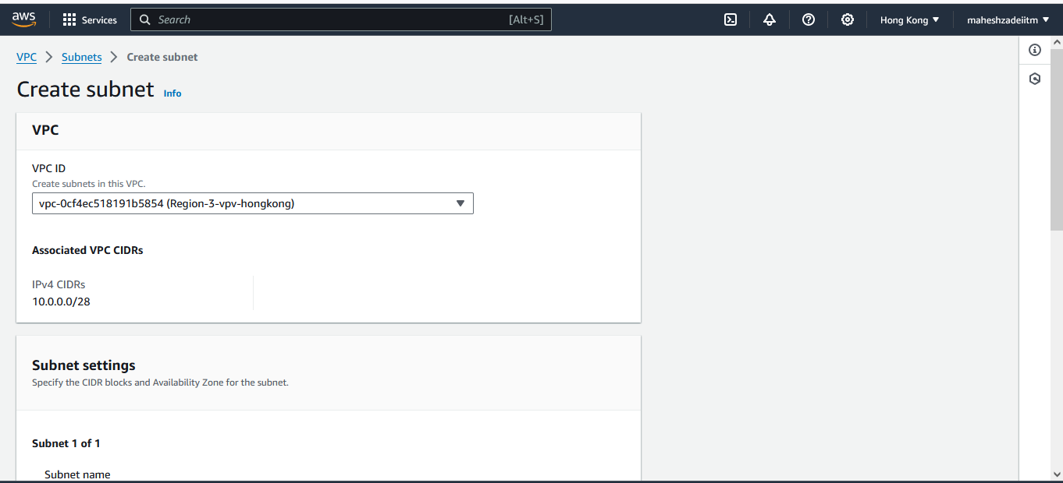

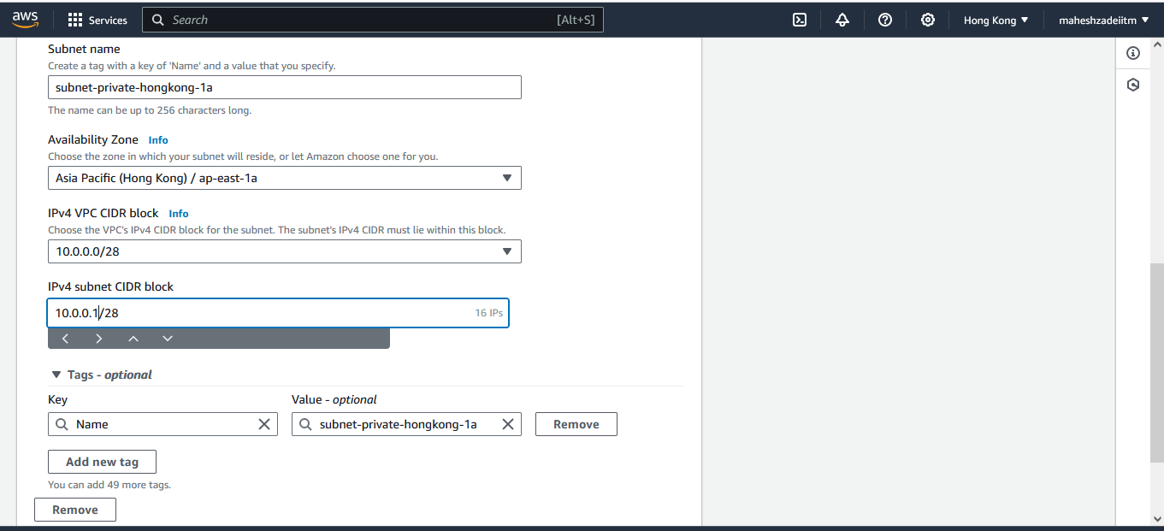

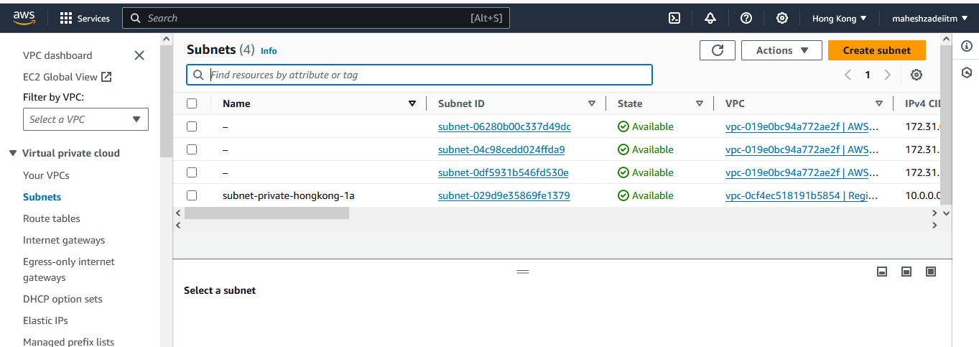

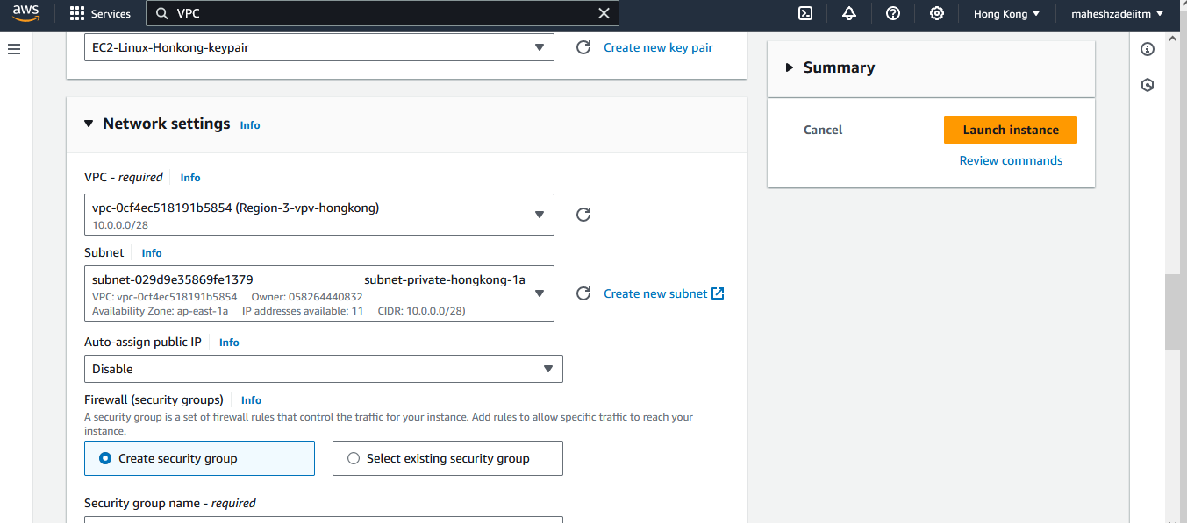

Public IP is disabled

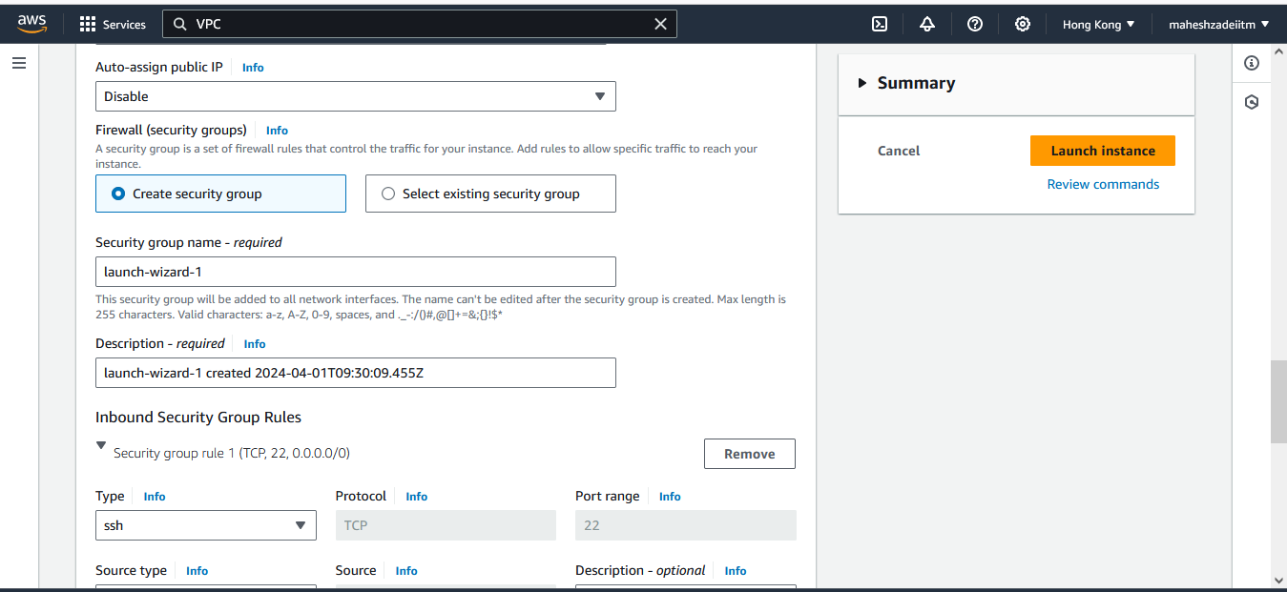

Now Launch Instance

Now EC2-Linux Instance created in Region -3 – Hongkong and now copy the private IP

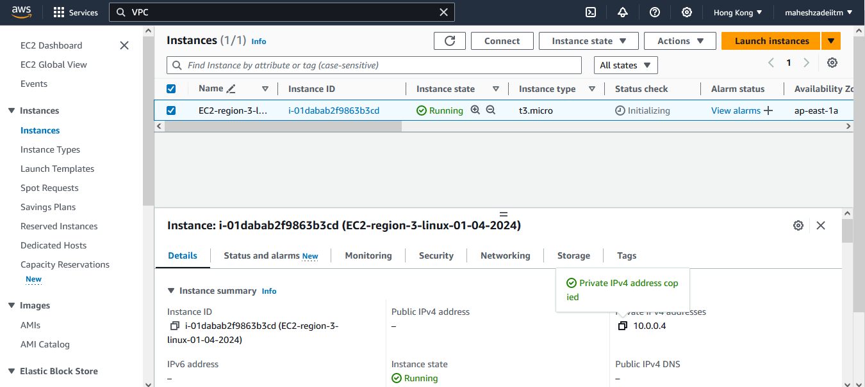

Copy keypair on EC2 linux machine in Mumbai DC EC2 windows machine to connect the Linux machine from honking DC

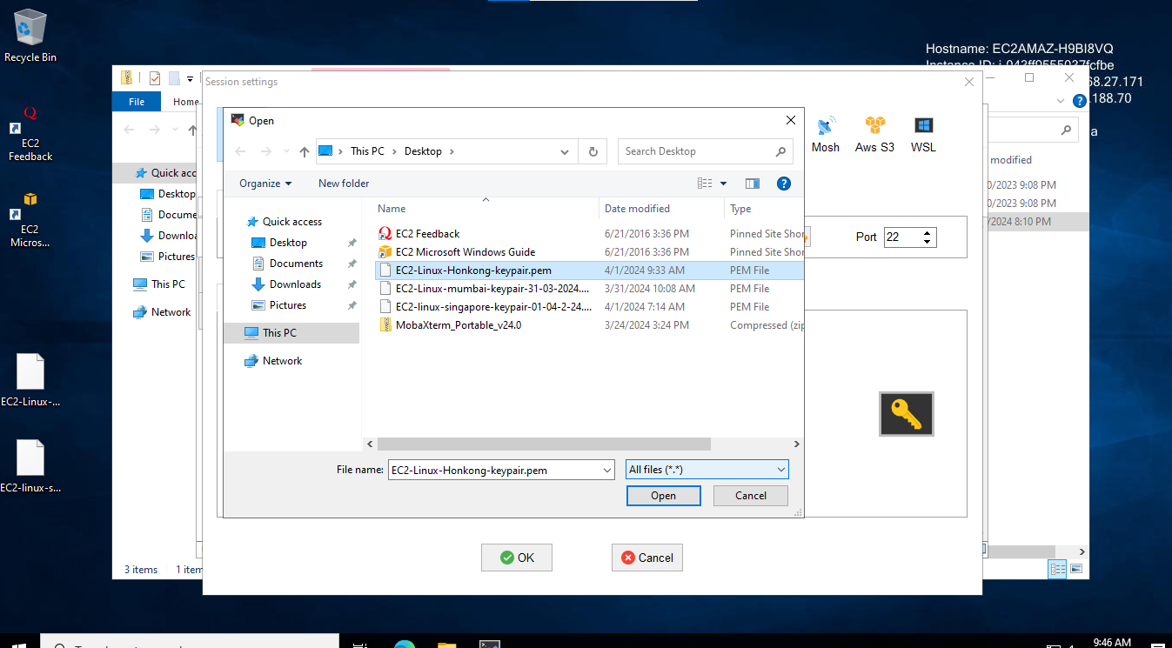

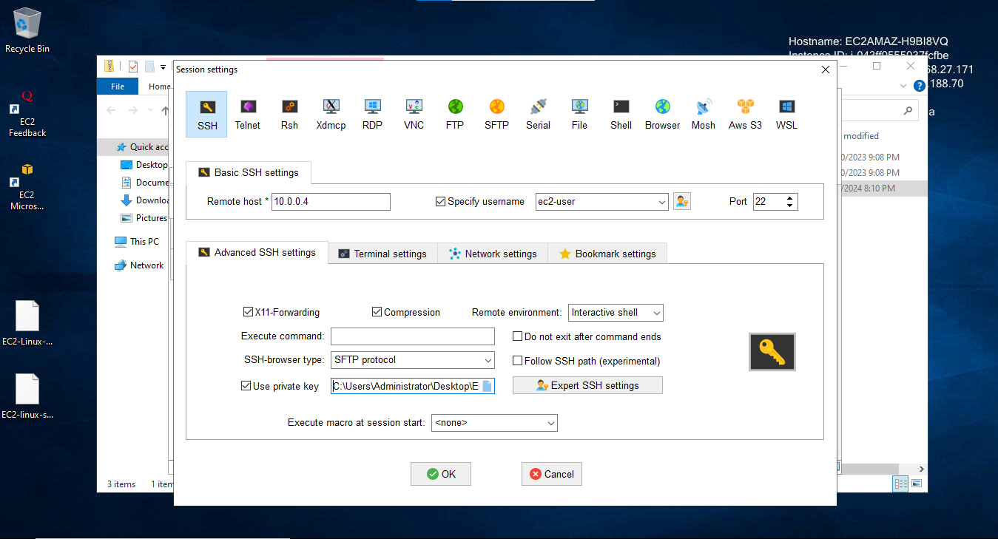

Now click on OK to connect EC2 Linux machine .

Its not connecting

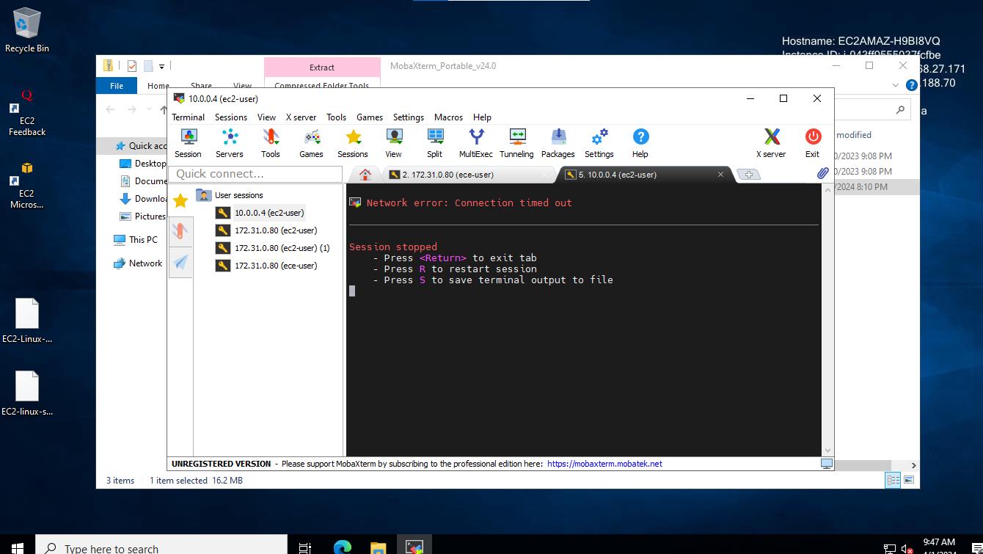

Try to connect from the Region 1 to Region 3 and see if that works or not??????

Its not connecting.( Can you pls clarify why the EC2 instance is not connecting from Region 1 to Region 3

Pls check and confirm .

Regards,

Mahesh Zade